4th January 2021

Dear Parent/Carer

We would like to wish you all a very Happy New Year and hope that this letter finds you well and safe.

I am sure you will have been following the news and the ongoing discussions around whether schools should move to remote learning for the start of the new term in order to allow the infection rate of the new Covid variant to stabilise.

Trade Unions are calling on the Government to move to remote learning at the start of the new term as they state that the science suggests that the rate of infection will only decrease if schools remain closed to the majority of pupils. They are recommending that schools provide remote learning to the majority of pupils but remain open to priority pupils and the children of key workers.

Trade Unions have contacted all members and as a result of this there is no alternative but to close our schools from Tuesday the 5th January 2021 for all pupils except those of key workers and priority children. All other children will be expected to access their school work via Google Classroom. Further details of this will be shared by your individual school.

Below is a link to the latest key worker categories. If you believe you are a key worker, please check this list:

https://www.gov.uk/government/publications/coronavirus-covid-19-maintaining-educational-provision/guidance-for-schools-colleges-and-local-authorities-on-maintaining-educational-provision

Your child’s school will send out further information regarding how to confirm that your child will attend school under key worker status.

We hope to continue with breakfast and after school provision for key worker and priority children during this time and will confirm this with you later today.

At this point in time you will have many questions regarding home school support, remote learning, IT resources and school meal provision. Further information on all of these areas will be shared by individual schools later today.

Thank you for your continued support at this time.

Yours sincerely

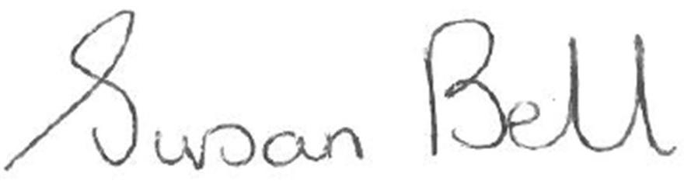
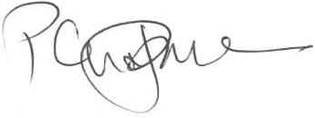

Susan Bell Peter Chapman
CEO Balmoral Learning Trust Chair of Directors, Balmoral learning Trust

