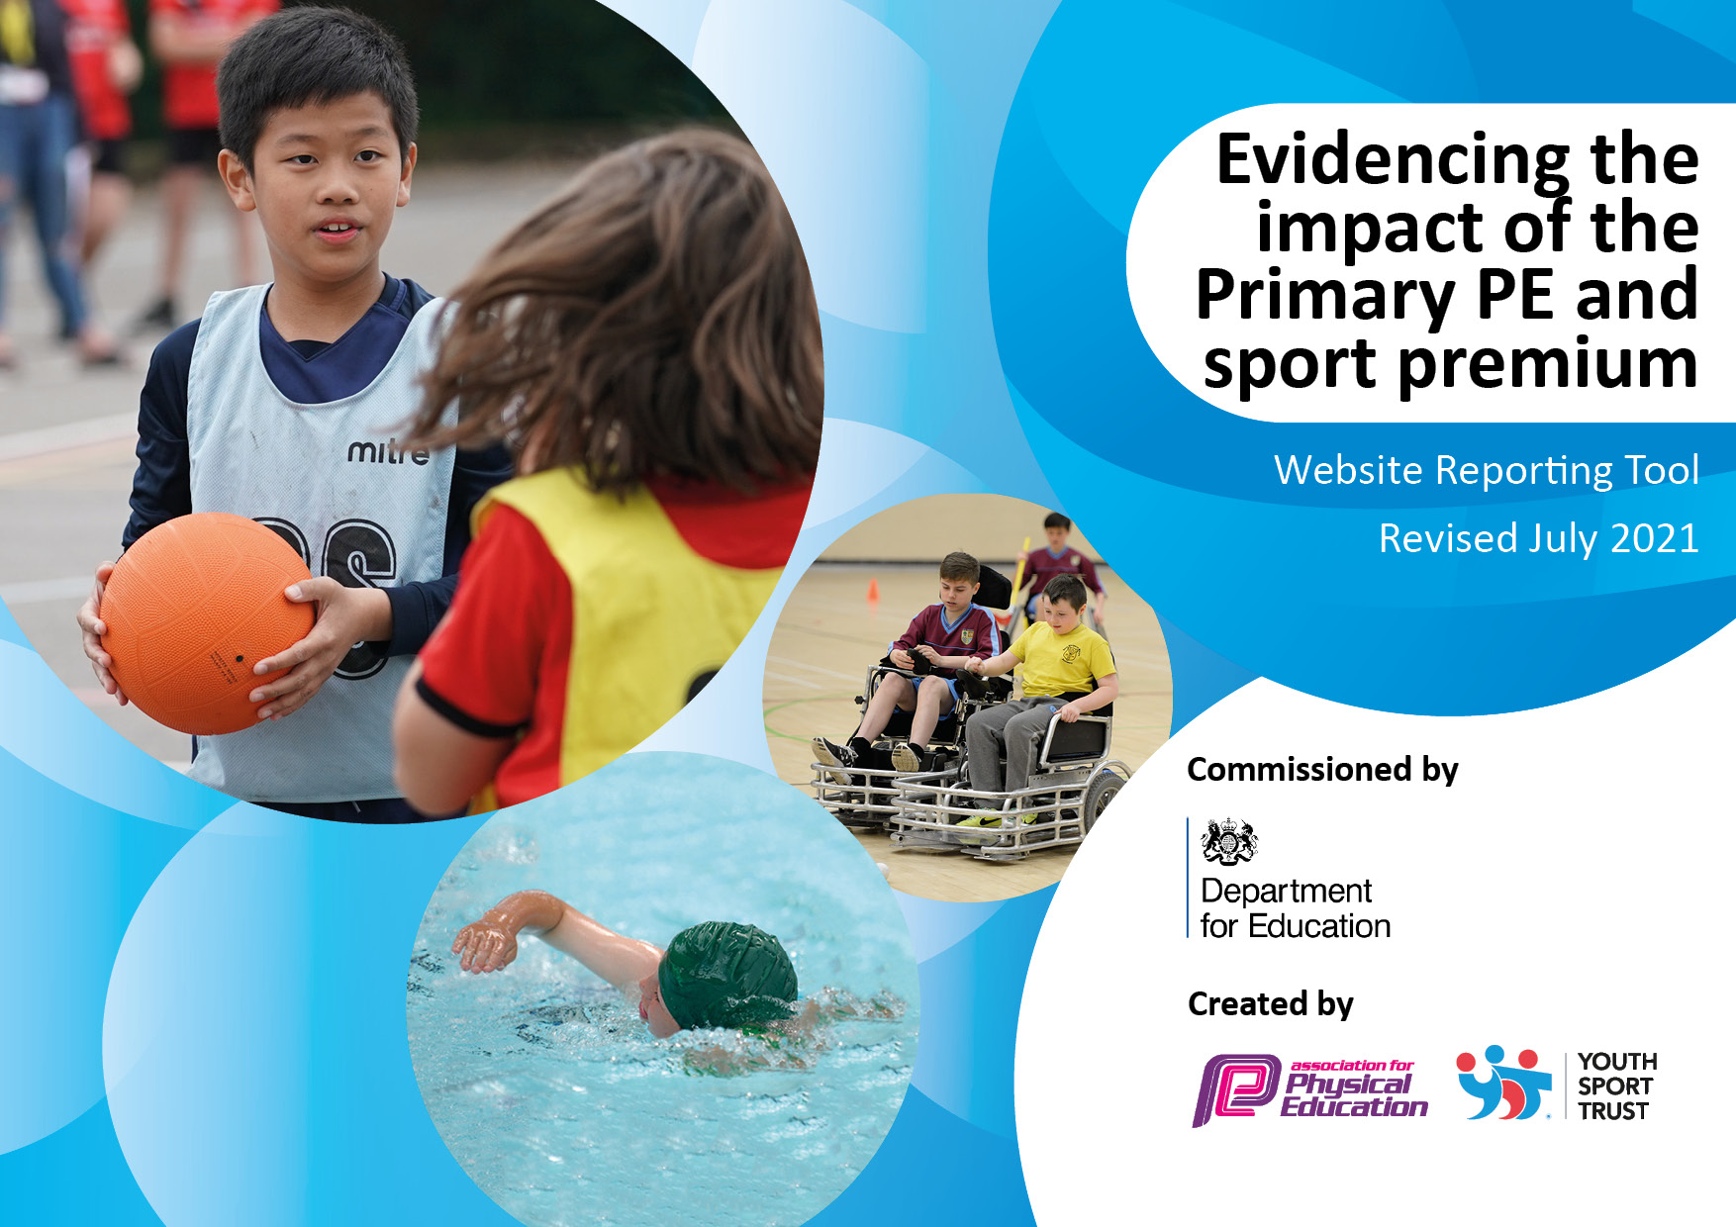
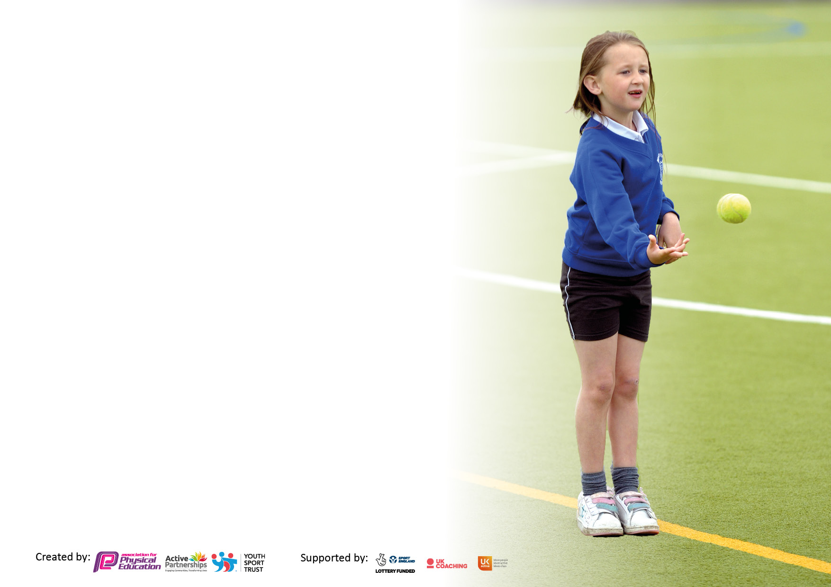

It is important that your grant is used effectively and based on school need. The Education Inspection Framework makes clear there will be a focus on ‘whether leaders and those responsible for governors all understand their respective roles and perform these in a way that enhances the effectiveness of the school’.

Under the Quality of Education Ofsted inspectors consider:
Intent - Curriculum design, coverage and appropriateness
Implementation - Curriculum delivery, Teaching (pedagogy) and Assessment
Impact - Attainment and progress

To assist schools with common transferable language this template has been developed to utilise the same three headings which should make your plans easily transferable between working documents.

Schools must use the funding to make additional and sustainable improvements to the quality of Physical Education, School Sport and Physical Activity (PESSPA) they offer. This means that you should use the Primary PE and sport premium to:

- Develop or add to the PESSPA activities that your school already offer
- Build capacity and capability within the school to ensure that improvements made now will benefit pupils joining the school in future years
- The Primary PE and sport premium should not be used to fund capital spend projects; the school’s budget should fund these.

Pleasevisitgov.ukfortherevisedDfEguidanceincludingthe5keyindicatorsacrosswhichschoolsshoulddemonstrate animprovement.Thisdocumentwillhelpyoutoreviewyourprovisionandtoreportyourspend.DfEencouragesschools to use this template as an effective way of meeting the reporting requirements of the Primary PE and sport premium.

We recommend you start by reflecting on the impact of current provision and reviewing the previous spend.

Schools are required to publish details of how they spend this funding, including any under-spend from 2019/2020, as well as on the impact it has on pupils’ PE and sport participation and attainment. All funding must be spent by 31st July 2022.

We recommend regularly updating the table and publishing it on your website throughout the year. This evidences your ongoing self-evaluation of how you are using the funding to secure maximum, sustainable impact. Final copy must be posted on your website by the end of the academic year and no later than the 31st July 2021. To see an example of how to complete the table please click HERE.

Details with regard to funding
Please complete the table below.

Total amount carried over from 2019/20 | £0
Total amount allocated for 2020/21 | £19,630
How much (if any) do you intend to carry over from this total fund into 2021/22? | £0
Total amount allocated for 2021/22 | £19,780
Total amount of funding for 2021/22. To be spent and reported on by 31st July 2022. | £19,780
Swimming Data
Please report on your Swimming Data below.

Meeting national curriculum requirements for swimming and water safety.

N.B. Complete this section to your best ability. For example you might have practised safe self-rescue techniques on dry land which you can then transfer to the pool when school swimming restarts.
Due to exceptional circumstances priority should be given to ensuring that pupils can perform safe self rescue even if they do not fully meet the first two requirements of the NC programme of study
What percentage of your current Year 6 cohort swim competently, confidently and proficiently over a distance of at least 25 metres?
N.B. Even though your pupils may swim in another year please report on their attainment on leaving primary school at the end of the summer term 2020.
Please see note above
What percentage of your current Year 6 cohort use a range of strokes effectively [for example, front crawl, backstroke and breaststroke]?
Please see note above
What percentage of your current Year 6 cohort perform safe self-rescue in different water-based situations?
Schools can choose to use the Primary PE and sport premium to provide additional provision for swimming but this must be for activity over and above the national curriculum requirements. Have you used it in this way? | Yes/No

Action Plan and Budget Tracking
Capture your intended annual spend against the 5 key indicators. Clarify the success criteria and evidence of impact that you intend to measure to evaluate for pupils today and for the future.

Academic Year: 2020/21 | Total fund allocated: | Date Updated:
Key indicator 1: The engagement of all pupils in regular physical activity – Chief Medical Officers guidelines recommend that primary school pupils undertake at least 30 minutes of physical activity a day in school |  |  |  | Percentage of total allocation:
 |  |  |  | %
Intent | Implementation |  | Impact
Provide all students with two hours of timetabled Physical Education per week (within the curriculum only) and have extra curriculum provision inclusive of physical activity in addition to this. Use opportunities in Maths and English to enhance learning through physical activity (weekly lessons). Use staff meetings to review and share good practise. | Reintroduction of the run a mile.  Lunchtimes CL to train playground leaders to lead active lunchtimes HT lead whole assembly to re-launch lunchtimes. Developed KS1/2 playground with equipment to increase levels of physical activity at break and lunchtimes.n | £1930 | Increased awareness of sports club  Build on taster sessions in school  Less active children identified  Lunchtime clubs Set-up  Through active lunchtime opportunities developed this year pupils have increased their fitness levels and report that enjoy lunchtimes. They have improved their confidence and self-esteem through leadership opportunities on offer and behaviour and engagement in afternoon sessions has improved. Emotional health and wellbeing has been focussed on this year and pupils and staff have a number of strategies to help deal with situations that cause stress or anxiety. The profile of health and wellbeing in school is high and there are lots of resources available to support pupils understanding. Through activities on offer both in PE and Opal they are developing their understanding of how to deal with their emotions and also developing life skills such as trust, respect, teamwork and communication.  Evidence, staff feedback, parental feedback, photographic evidence.
Key indicator 2: The profile of PESSPA being raised across the school as a tool for whole school improvement |  |  |  | Percentage of total allocation:
 |  |  |  | %
Intent | Implementation |  | Impact
PE Curriculum Developments To discuss with staff the implications of the covid-19 situation and what this means for PE in terms of curriculum design and order of activities. Embed staff confidence in following new curriculum overview and  progression of skills documents. To ensure all staff are able to deliver high quality PE lessons with clear skill based focus To update all documentation for PE health and safety in line with new guidance in safe practice book. | PE Curriculum PE lead to run staff meeting on curriculum overview that has been put in place following tweaks and changes put in place. PE CPD needs planned for the year based on staff feedback and monitoring activities conducted; Real PE training to be updated and 8 staff have yet to complete the training due to new staff and maternity leave PE lead to attend  PE conference: 1June 2022 1-1 sessions throughout the year: Autumn, spring & summer Monitoring activities planned to judge impact of the spend – lesson observations, questionnaires etc Other staff CPD?: Dance?? | £2650  Real PE | New curriculum that is now in place will ensure good progression and continuity throughout the school so that pupils make good progress in PE and develop the skills they need in order for them to be successful later on in life. Pupils feedback about their enjoyment of lessons and can talk about the skills they have learnt and can talk about the importance of being active and staying healthy and their love of PE. School, PE leader and staff remain up to date with latest guidance and best practice in the subject through sharing ideas and this ensure the best possible impact and outcomes for pupils

Key indicator 3: Increased confidence, knowledge and skills of all staff in teaching PE and sport |  |  |  | Percentage of total allocation:
 |  |  |  | %
Intent | Implementation |  | Impact
PE Curriculum Developments To discuss with staff the implications of the covid-19 situation and what this means for PE in terms of curriculum design and order of activities. Embed staff confidence in following new curriculum overview and progression of skills documents. To ensure all staff are able to deliver high quality PE lessons with clear skill based focus To update all documentation for PE health and safety in line with new guidance in safe practice book. Improve staff subject specific knowledge in swimming and increase number of pupils meeting recommendations. | PE Curriculum  PE lead to run staff meeting on curriculum overview that has been put in place following tweaks and changes put in place.  PE CPD needs planned for the year based on staff feedback and monitoring activities conducted;  PE lead to attend network meetings:  Autumn, spring & summer Monitoring activities planned to judge impact of the spend – lesson observations, questionnaires etc  Other staff CPD?:  Developing pupils area of learning in EYFS look at opportunities to develop and enhance pupils physical skills through: New facilities and opportunities on offer such as climbing facilities, balance bikes and other equipment needed for continuous provision.  EYFS lead and PE lead to develop EYFS physical baseline and look at support materials for delivering quality PE lessons and other informal physical activity opportunities. | £4200  Real PE | New curriculum( Real PE) that is now in place will ensure good progression and continuity throughout the school so that pupils make good progress in PE and develop the skills they need in order for them to be successful later on in life.  Pupils feedback about their enjoyment of lessons and can talk about the skills they have learnt and can talk about the importance of being active and staying healthy and their love of PE. School, PE leader and staff remain up to date with latest guidance and best practice in the subject through sharing ideas and this ensure the best possible impact and outcomes for pupils  Early years pupils develop good physical skills through the curriculum and opportunities on offer which give them a good start and baseline for future engagement and activities. There is an increased number of pupils meeting national curriculum swimming requirements. Quality of swimming lessons is good and pupils enjoy attending these. Evidence : Lesson observations, planning documents, Learning walks, Staff feedback. Pupil and parent feedback. Staff performance management PE policy and risk assessments.
Key indicator 4: Broader experience of a range of sports and a  ctivities offered to all pupils |  |  |  | Percentage of total allocation:
Intent | Implementation |  | Impact
Use strategies to target less active children and promote interest in physical activity  Increase participation in disability sports | Use data from extra-curricular activities to identify less active children. CM to carry out lunch time groups (How to train as a Jedi)  CM to take after-school clubs (LINKS TO Comp and sports premium funded) – make activity free as funded by sports premium – Opportunity for all.  Entry to festivals. Utilise tiered competition to provide more opportunities to children and a positive experience of sport  Enter more teams in disability sports such as Boccia, thereby increasing participation, broadening experiences and providing opportunities.  Children to be entered in Sportsability competitions | £8500 | More children are active for 30 minutes each day  More children taking part in extra-curricular activities  School provides links to clubs  Children can talk about the benefits of exercise to physical and mental well-being  More children participating in physical activity and sports not usually offered or have access to  Children build on opportunity to attend external sports clubs

Key indicator 5: Increased participation in competitive sport |  |  |  | Percentage of total allocation:
 |  |  |  | %
Intent | Implementation |  | Impact
Additional achievements:  Competition and Community To continue to increase the awareness and engagement of parents in health and sports activities. To continue to offer a range of competitive opportunities for all pupils. To increase links with community clubs and organisations. | To continue to review school games mark and continue with the competitive opportunities on offer in achieving appropriate award for the school- continue to maintain Gold award status. To adapt calendar of sporting events put together throughout the year, including intra competitions & clubs on offer in light of Covid 19. To continue to signpost parents to club links event, PE courses and advice and continue to develop ‘PE and Physical Activity’ section on school website to help encourage pupils and families to be more physically active and further improve their skills. Extra curricular clubs and competitions Get back up and running with clubs and competitions to enhance wider PE and sport offer for pupils. This will be done in line with government guidance . | £2500 | Pupils developing and applying key life skills through their participation in PE and sport including trust, respect, teamwork and communication. Increased number of pupils participating in competitive opportunities and reporting increased enjoyment in these. Evidence: Lunchtime observations, Extracurricular registers, competition calendar and results. Staff feedback, pupils voice from school council.

Signed off by
Head Teacher: | V Wilson
Date: | 24.11.21
Subject Leader: | A Ryder
Date: | 24.11.21
Governor: | H Lawrence
Date: | 25.11.21

