Hetton Lyons
Calculation Policy
2022 - 2023
Policy Overview

Principles of the Policy
One of the key learning principles behind this policy is the concrete pictorial abstract approach (CPA). The concrete-pictorial-abstract approach, is based on research by psychologist Jerome Bruner, and suggests that there are three steps (or representations) necessary for children to develop understanding of a concept.
For children to have a deep understanding of the mathematical concepts being developed, they need to ‘master’ all three phases of the CPA approach. If a child has moved on from the concrete to the pictorial, it does not mean that the concrete cannot be used alongside the pictorial as an additional scaffold. If a child is working at the abstract stage, ‘proving’ something or ‘working out’ then concrete or pictorial representations could be used to develop a greater depth as pupils articulate their thinking /reasoning. Reinforcement is achieved by going back and forth between these representations. Linking abstract notation to pictorial/concrete representations and then the concrete/pictorial models to an abstract notation.

Concrete Representation
The enactive stage. Children are first introduced to an idea/skill/concept by acting it out with real objects, this could include large scale with the pupils themselves and also utilise resourced available in the outdoor environment. This is a 'hands on' stage using real objects linked to real-life and the wider curriculum and/or mathematical equipment, (i.e. counters, cubes, bead string, five and ten frames, Dienes, place value counters etc.) and it is the foundation for conceptual understanding.

Pictorial Representation
The iconic stage. A child has sufficiently understood the hands-on, concrete experiences performed and can now relate them to pictorial representations, such as a diagram or pictures of the problem. Pictorial representations, such as the bar model, can also be used to scaffold understanding.

Abstract Representation
The symbolic stage. A child is now capable of representing problems by using abstract mathematical notation, for example: 12 ÷ 2 = 6. This is the ultimate mode.
Teachers should understand how each stage of the CPA approach can be used effectively to model concepts, scaffold learning and record thinking:
Modelling: teachers to make clear links are made between concrete representations (which can also be represented pictorially), pictorial representations (diagrams and pictures, including bar modelling) and abstract notations.
Scaffolds: children to be offered the opportunity to use appropriate concrete and pictorial representations to further scaffold their understanding. The scaffolds offered, must be familiar and understood by children. Children should be encouraged to consider whether scaffolds are required and for how long they require them for. Concrete and pictorial representations are also supportive when developing children’s depth of knowledge through problem solving and reasoning experiences.
Recording:
Concrete recording: when children are unable to record their thinking using pictorial representation or abstract notation then their learning can be evidenced through photographic evidence and post-it notes, which detail key information regarding children’s strengths and areas of developments/gaps/misconceptions.
Pictorial recording: children to be encouraged to represent their thinking using pictorial representations, if they are unable to record using abstract notation. Pictorial representation also includes the use of the bar model.
Abstract recording: this is the ultimate mode but should not be rushed at the expense of true conceptual understanding. Scaffolds, such as missing box calculations, can support children’s transition towards abstract.

Big Ideas

The next section of the policy highlights the ‘big ideas’ for each year group and the number facts that children should be able to recall.

Big Ideas - This highlights the big ideas in place value, addition and subtraction and multiplication and division for each year group. These big ideas should be a focus throughout the year.

Derive & recall, mental skills, strategies & methods – This highlights the mental skills and strategies that children need in each year group. Children should have a ‘Daily Maths’ session each day. The session should last for around 10 -15 minutes and can be part of the Maths lesson or at a separate part in the day. The objectives under the heading of derive & recall, mental skills, strategies & methods should be focused on in these sessions.

Year 1

Year 1 Progression Place Value and Counting

Place Value Big Ideas

- The position a digit is placed in a number determines its value.
- The language used to name numbers does not always expose the place value, for example the word ‘twelve’ does not make it transparent that the value of this number is ten and two. It is important that children develop secure understanding of the value of each digit.
- Place value is based on unitising: treating a group of things as one ‘unit’. In mathematics, units can be any size, for example units of 1, 2, 5 and 10 are used in money. In place value units of 1 (one), 10(ten) and 100 (hundred) are used.

Place Value: derive & recall, mental skills, strategies & methods
Year 1 Autumn Term:  Place Value and Counting | Count to 10 then 20 forwards and backwards, beginning with 0 or 1, or any given number. | Recognise and say numbers in the environment and with personal significance as appropriate  (i.e. age, door number etc.). | Recognise, say and identify numerals to 10 then 20. | Say the numbers 0-10 then 0 - 20 in a random order. | Order numbers to 10 then 20 positioning them on a number track. | Count reliability objects up to 20. | Estimate and check by counting. | Instantly recognise, without counting (subitise), organised (up to 10) and random arrangements (up to 5) of small numbers of objects. | Use the language of: equal to, more than, less than (fewer), most, least (numbers within 20).

- Year 1 Spring Term:  - Place Value and Counting | Count to 40, forwards and backwards, beginning with 0 or 1, or any given number. | Recognise and say numbers in the environment as appropriate and with personal significance as appropriate (i.e. age, door number etc.). | Recognise, say and identify numerals to 40. | Say the numbers 0-40 in a random order. | Count reliability objects up to 40. | Estimate and check by counting. | Use the language of: equal to, more than, less than (fewer), most, least (numbers within 40).

Year 1 Summer Term:  Place Value and Counting | Count to and across 100, forwards and backwards, beginning with 0 or 1, or any given number. | Recognise and say numbers in the environment as appropriate and with personal significance as appropriate (i.e. age, door number etc.). | Recognise, say and identify numerals to 100. | Say the numbers 0-100 in a random order. | Count reliability objects up to 100. | Estimate and check by counting. | Use the language of: equal to, more than, less than (fewer), most, least (numbers within 100).

Year 1 Progression: Addition & Subtraction

Addition & Subtraction Big Ideas

- Relating numbers to 5 and 10 helps develop knowledge of the number bonds within 20. For example, given 8 + 7, thinking of 7 as 2 + 5 and adding the 2 to 8 to make 10 and then the 5 to total 15.
- Thinking of part whole relationships is helpful in linking addition and subtraction. For example, where the whole is 6, and 4 and 2 are parts. This means that 4 and 2 together form the whole, which is 6 and 6 subtract 4 leaves the 2 and 6 subtract 2 leaves the 4.

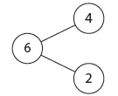

- Year 1 Autumn Term: Addition & Subtraction: derive & recall, mental skills, strategies & methods | - Number pairs with a total of 10,  (e.g. 3 + 7, what to add to a single-digit number to make 10, e.g. 3 + □ = 10). | - Addition doubles for all numbers to 5 (total of 10) then 10 (total of 20),  - (e.g. 8 + 8). | - Addition and subtraction facts for all numbers to a total of 10, including zero  - (e.g. 3 + 4, 8 – 5). | Identify one more and one less within 10 then 20. | - Add or subtract a pair of single-digit numbers, including crossing the tens boundary, within 20, (e.g. 4 + 5, 5 + 6, 8 – 3, 9 - 4).  Aggregation: counting each group and then counting all  Augmentation: counting on from a number, including counting on from the largest number (reorder when adding)  partition: bridge through 10 when adding,  (e.g. 7 + 5 = 7 + 3 + 2)  count on or back in 1s or 2s  use knowledge of pairs making 10 | - Add and subtract groups of small single-digit numbers,  - (e.g. 5 – 3 + 2).  - reorder numbers when adding  - identify pairs totalling 10 or make doubles | - Add or subtract a single-digit number to or from a teens number , including crossing the tens boundary for subtraction, within 20,  - (e.g. 13 + 5, 12 – 4, 17 – 3).  reorder numbers when adding, (e.g. put the larger number first  partition and combine tens and ones  count on or back in 1s, 2s or 10s  - partition: bridge through 10 when subtracting, (e.g. 13 - 5 = 13 – 3 – 2)

- Year 1 Spring Term: Addition & Subtraction: derive & recall, mental skills, strategies & methods | - Addition doubles for all numbers to 5 (total of 10) then 10 (total of 20),  - (e.g. 8 + 8). | - Addition and subtraction facts for all numbers to a total of 20, including zero,  (e.g. 13 + 4, 18 – 5). | - Identify one more and one less, within 40. | - Add a multiple of 10 to a single-digit number, within 40,  - (e.g. 7 + 30).  reorder numbers when adding, (e.g. put the larger number first) | - Add near doubles to with numbers to 10,  - (e.g. 6 + 7).  partition: double and adjust, (e.g. 5 + 6 = 5 + 5 + 1) | - Add and subtract a two-digit number and ones, including crossing the tens boundary, within 40,  - (e.g. 24 + 3, 24 + 7, 36 – 3, 36 – 8). | - Add and subtract a two-digit number and tens, within 40,  - (e.g. 24 + 10, 14 + 20, 36 – 10, 36 – 20). | Add and subtract two, two-digit numbers, including crossing the tens boundary, within 40,  - (e.g. 24 + 13, 24 + 17, 36 – 13, 36 –1 8).

- Year 1 Summer Term: Addition & Subtraction: derive & recall, mental skills, strategies & methods | - Addition doubles for all numbers to 5 (total of 10) then 10 (total of 20),  - (e.g. 8 + 8). | - Identify one more and one less, within 100. | - Add and subtract one-digit and two-digit numbers to 20, including zero, (e.g. 13 + 4, 18 – 5).

Year 1 Progression Multiplication and Division

Multiplication and Division Big Ideas

- Counting in steps of equal sizes is based on the big idea of ‘unitising’; treating a group of, say, five objects as one unit of five.
- Working with arrays helps pupils to become aware of the commutative property of multiplication, that 2 × 5 is equivalent to 5 × 2.

Year 1 Autumn Term: Multiplication & Division: rapid recall facts, mental skills, strategies & methods | Doubles of all numbers to 10 and corresponding halves,  (e.g. double 6). | Odd and even numbers to 20, (e.g. use patterns of last digits and make links to counting in twos for even numbers,  (e.g. 0, 2, 4, 6, 8). | Count on from and back to zero in twos, (e.g. use patterns of last digits and make links to even numbers, (e.g. 0, 2, 4, 6, 8). | Count on from and back to zero in fives, (e.g. use patterns of last digits, (e.g. 0 and 5). | Count on from and back to zero in tens, (e.g. use patterns of last digits, (e.g. 0). | Solve one-step problems involving multiplication and division, by calculating the answer using concrete objects, pictorial representations and arrays with the support of the teacher.

Year 1 Spring Term: Multiplication & Division: rapid recall facts, mental skills, strategies & methods | Doubles of all numbers to 10 and corresponding halves,  (e.g. double 6). | Odd and even numbers to 40, (e.g. use patterns of last digits and make links to counting in twos for even numbers,  (e.g. 0, 2, 4, 6, 8). | Count in multiples of twos, (e.g. use patterns of last digits and make links to even numbers, (e.g. 0, 2, 4, 6, 8). | Count in multiples of fives, (e.g. use patterns of last digits, (e.g. 0 and 5). | Count in multiples of tens, (e.g. use patterns of last digits, (e.g. 0). | solve one-step problems involving multiplication and division, by calculating the answer using concrete objects, pictorial representations and arrays with the support of the teacher

Year 1 Summer Term: Multiplication & Division: rapid recall facts, mental skills, strategies & methods | Doubles of all numbers to 10 and corresponding halves,  (e.g. double 6). | Odd and even numbers to 100, (e.g. use patterns of last digits and make links to counting in twos for even numbers,(e.g. 0, 2, 4, 6, 8). | Count in multiples of twos, (e.g. use patterns of last digits and make links to even numbers, (e.g. 0, 2, 4, 6, 8). | Count in multiples of fives, (e.g. use patterns of last digits, (e.g. 0 and 5). | Count in multiples of tens, (e.g. use patterns of last digits, (e.g. 0). | Solve one-step problems involving multiplication and division, by calculating the answer using concrete objects, pictorial representations and arrays with the support of the teacher.

Year 2
Year 2 Progression Place Value and Counting

Place Value Big Ideas

- The position (place) of a digit in a number determines its value. Hence the term place value.

Count in steps of 2 from 0, forwards and backwards, within 100. | Count in steps of 5 from 0, forwards and backwards, within 100. | Count in steps of 10 from 0, forwards and backwards from any number, within 100. | Count in steps of 3 from 0, forwards and backwards. | Compare and order numbers from 0 to 100. | Demonstrate an understanding of place value, with apparatus to support still if necessary, within 100,  (e.g. stating the difference between the tens and ones and writing statements using > & < symbols) | Recognise the place value of each digit in a two digit number, within 100. | Partition two-digit numbers into different combinations of tens and ones, this may include apparatus, within 100,  (e.g. 23 is the same as 2 tens and 3 ones, same as 1 ten and 13 ones)

Year 2 Progression Addition & Subtraction

Addition & Subtraction Big Ideas

- Understanding that addition of two or more numbers can be done in any order is important to support children’s fluency. When adding two numbers it can be more efficient to put the larger number first. For example, given 3 + 8 it is easier to calculate 8 + 3.
- When adding three or more numbers it is helpful to look for pairs of numbers that are easy to add. For example, given 5 + 8 + 2 it is easier to add 8 + 2 first than to begin with 5 + 8.
- Understanding the importance of the equals sign meaning ‘equivalent to’ (i.e. that 6 + 4 = 10, 10 = 6 + 4 and 5 + 5 = 6 + 4 are all valid uses of the equals sign) is crucial for later work in algebra. Empty box problems can support the development of this key idea. Correct use of the equals sign should be reinforced at all times. Altering where the equals sign is placed develops fluency and flexibility.

Addition & Subtraction: derive & recall, mental skills, strategies & methods
- Addition and subtraction facts for all numbers to 20,  (e.g. 9 + 8, 17 – 9, drawing on knowledge of inverse operations) | Derive and use related facts to 100,  (e.g. 3 + 4 = 7, 30 + 40 = 70 etc.) | All pairs of multiples of 10 (to a total of 100),  (e.g. 30 + 70, or 60 + □ = 100) | What must be added to any two-digit number to make the next multiple of 10,  (e.g. 52 + □ = 60) | - Addition doubles for all numbers to 20 (total of 40)  (e.g. 18 +1 8). | Addition doubles for all multiples of 10 to 100,  (e.g. 40 + 40) | Add near doubles, within 100,  (e.g. 13 + 14, 39 + 40) | Add & subtract any single-digit number to or from a multiple of 10, within 100,  (e.g. 60 + 5, 80 - 5)

Written Procedures

Add or subtract a single-digit number to or from a two-digit number, within 100, without crossing the tens boundary, (e.g. 23 + 5, 57 – 3) | Add or subtract a single-digit number to or from a two-digit number, within 100, crossing the tens boundary,  (e.g. 28 + 5, 52 – 7) | Add or subtract a multiple of 10 to or from any two-digit number, within 100, (e.g. 27 + 60, 72 – 50) | Add or subtract a two-digit number to or from a multiple of 10, within 100, (e.g. 50 + 38, 90 – 27) | Add and subtract two-digit numbers , without crossing the tens boundary, within 100, (e.g. 34 + 65, 68 – 35) | Add and subtract two-digit numbers, crossing the tens boundary, within 100,  (e.g. 38 + 65, 64 – 35) | Add 9, 19, 29, 11, 21, 31 etc.

Year 2 Progression Multiplication & Division

Multiplication & Division Big Ideas

- It is important that pupils both commit multiplication facts to memory and also develop an understanding of conceptual relationships. This will aid them in using known facts to work out unknown facts and in solving problems.
- Pupils should look for and recognise patterns within tables and connections between them (e.g. 5× is half of 10×).
- Pupils should recognise multiplication and division as inverse operations and use this knowledge to solve problems. They should also recognise division as both grouping and sharing.
- The recognition of pattern in multiplication helps pupils commit facts to memory, for example doubling twice is the same as multiplying by four, or halving a multiple of ten gives you the related multiple of five.

Multiplication & Division: rapid recall facts, mental skills, strategies & methods
Doubles of all numbers to 20, and the corresponding even halves,  (e.g. double 13, halve 26). | Find half of even numbers to 100.  use knowledge that halving is the inverse of doubling  partition: halve the tens and ones separately, then recombine | Doubles of multiples of 10 to 100, and the corresponding halves.  (e.g. double 40, halve 80)  use knowledge that halving is the inverse of doubling | Multiplication facts for the 2 times-tables, and the corresponding division facts. | Multiplication facts for the 5 times-tables, and the corresponding division facts. | Multiplication facts for the 10 times-tables, and the corresponding division facts. | Odd and even numbers to 100.

Find the total number of objects when they are organised into groups of 2, 5 or 10.  use knowledge of multiplication facts from the 2, 5 and 10 times-tables,  (e.g. recognise that there are 15 objects altogether because there are three groups of five) | Calculate mathematical statements for multiplication and division with the 2, 3, 5, & 10 times tables, (e.g. using arrays).  show that multiplication of two numbers can be done in order (commutative) and division of one number by another cannot | Understand multiplication as repeated addition and arrays.  show that multiplication of two numbers can be done in order (commutative) and division of one number by another cannot | Understand division as sharing and grouping. | Know that a division calculation can have a remainder.

Year 3
Year 3 Progression Place Value and Counting

Place Value Big Ideas
- The value of a digit is determined by its position in a number.
- Place value is based on unitising, treating a group of things as one ‘unit’. This generalises to 3 units + 2 units = 5 units (where the units are the same size).

Count from 0 in multiples of 4. | Count from 0 in multiples of 8. | Count from 0 in multiples of 50. | Count from 0 in multiples of 100. | Compare and order numbers to 1000. | Recognise the place value of each digit in a three-digit number ,  (e.g. hundreds, tens and ones.) | Read Roman numerals to 12. | Find 10 more and 10 less than a given number, up to 1000. | Find 100 more and 100 less than a given number, up to 1000.

Year 3 Progression: Addition & Subtraction

Addition & Subtraction Big Ideas
- Relating numbers to 5 and 10 helps develop knowledge of the number bonds within 20. For example, given 8 + 7, thinking of 7 as 2 + 5, and adding the 2 and 8 to make 10, then the 5 to 15. This should then be applied when calculating with larger numbers.
- Subtraction bonds can be thought of in terms of addition: for example, in answering 15 – 8, thinking what needs to be added to 8 to make 15. Counting on for subtraction is a useful strategy that can also be applied to larger numbers.

Addition & Subtraction: derive & recall, mental skills, strategies & methods
- Sums and differences of multiples of 10, within 100  (e.g. 50 + 40, 90 – 30) | Sums and differences of pairs of multiples of 10, & 100, including crossing the  tens boundary, within 1000  (e.g. 50 + 80, 120 – 90, 300 + 400) | Pairs of two-digit numbers with a total of 100,  (e.g. 32 + 68, or 32 + □ = 100) | Addition doubles of numbers 1 to 100, (e.g. 38 + 38) | Add and subtract a near multiple of 10, including crossing the tens boundary, (e.g. 56 + 29, 86 – 38)  partition: add or subtract a multiple of 10 and adjust,  (e.g. 56 + 29 = 56 + 30 – 1, or 86 – 38 = 86 – 40 + 2) | Add near doubles of two-digit numbers),  (e.g. 18 + 16, 38 + 37, 60 + 70, 50 + 70)  partition: double and adjust | Add and subtract a three-digit number and ones, including crossing tens boundary, (e.g. 472 + 4, 476 – 4, 389 + 5, 384 - 7)

Add and subtract a two-digit or three-digit multiple of 10,  (e.g. 120 – 40, 140 + 150, 370 – 180)  use knowledge of place value and related calculations, (e.g. work out 140 + 150 = 290 using 14 + 15 = 29) | Add and subtract a three-digit number and tens, including crossing the hundreds boundary,  (e.g. 356 + 30, 356 + 80) | Add and subtract a three-digit number and hundreds  (e.g. 459 + 300) | Add and subtract two three-digit multiples of 10,  (e.g. 620 – 380, 350+ 360) | Add and subtract a near multiple of 10 or 100 to any two-digit or three-digit number,  (e.g. 235 + 198) | Find the difference between near multiples of 100,  (e.g. 607 – 588)

Written Procedures

Add numbers with two digits and three digits, using formal written methods of columnar addition, without crossing boundaries | Add numbers with two digits and three digits, using formal written methods of columnar addition , crossing boundaries | Subtract numbers with two digits and three digits, using formal written methods of columnar subtraction, without crossing boundaries | Subtract numbers with two digits and three digits, using formal written methods of columnar subtraction, crossing boundaries

Year 3 Progression Multiplication and Division

Multiplication and Division Big Ideas
- It is important for children not just to be able to chant their multiplication tables but also to understand what the facts in them mean, to be able to use these facts to figure out others and to use in problems. It is also important for children to be able to link facts within the tables (e.g. 5× is half of 10×).
- They understand what multiplication means, see division as both grouping and sharing, and see division as the inverse of multiplication.

Multiplication & Division: rapid recall facts, mental skills, strategies & methods
Recall and use multiplication and division facts for the 3 multiplication tables | Recall and use multiplication and division facts for the 4 multiplication tables | Recall and use multiplication and division facts for the 8 multiplication tables | Doubles of all numbers 1 to 100 and corresponding halves | Halve any multiple of 10 up to 200 (e.g. halve 170)  partition: when halving, halve the tens and ones separately, then recombine | Multiply one-digit and two-digit numbers by 10, (e.g. 3 x 10, 46 x 10)  recognise that when multiplying by 10 the digits move one place to the left and zero is used as a place holder | Multiply one-digit and two-digit numbers by 100,  (e.g. 3 x 100, 46 x 100)  recognise that when multiplying by 100 the digits move two places to the left and zero is used as a place holder

Solve missing number problems using table facts from the 2, 5, 10, 3, 4 & 8 times tables | Solve positive integer scaling problems and corresponding problems in which n objects are connected to m objects | Write and calculate mathematical statements for multiplication and division facts from the 2, 5, 10, 3, 4 & 8 times tables | Identify the remainder when dividing by 2, 5 and 10 | Recognise that tenths arise from dividing an object into 10 equal parts and in dividing one-digit numbers or quantities by 10
Written Procedures

Multiply a two-digit number by a one-digit number using an informal layout (e.g. grid method) | Multiply a two-digit number by a one-digit number using a formal layout (e.g. short method)

Year 4

Year 4 Progression Place Value and Counting

Place Value Big Ideas
- Imagining the position of numbers on a horizontal number line helps us to order them: the number to the right on a number line is the larger number. So 5 is greater than 4, as 5 is to the right of 4. But –4 is greater than –5 as –4 is to the right of –5.
- Rounding numbers in context may mean rounding up or down. Buying packets of ten cakes, we might round up to the nearest ten to make sure everyone gets a cake.
- Estimating the number of chairs in a room for a large number of people we might round down to estimate the number of chairs to make sure there are enough.
- We can think of place value in additive terms: 456 is 400 + 50 + 6, or in multiplicative terms: one hundred is ten times as large as ten.

Count backwards through zero to include negative numbers | Count in multiples of 6 | Count in multiples of 7 | Count in multiples of 9 | Count in multiples of 25 | Count in multiples of 1000 | Find 1000 more and less than a given number | Compare and order numbers beyond 1000 | Compare numbers with the same number of decimals places (1.d.p.) | Compare numbers with the same number of decimal places (2.d.p.)

Read Roman numerals to 100 | Recognise the place value of each digit in a four-digit number  (e.g. thousands, hundreds, tens, ones) | Recognise the place value of digits in numbers to one decimal place  (e.g. ones, tenths) | Recognise the place value of digits in numbers to two decimal places  (e.g. ones, tenths, hundredths) | Identify the value of each digit in numbers to one decimal place | Round any number to the nearest 10, up to 10 000 | Round any number to the nearest 100, up to 10 000 | Round any number to the nearest 1000, up to 10 000 | Round decimals with one decimal place to the nearest whole number

Year 4 Progression: Addition & Subtraction

Addition & Subtraction Big Ideas
- It helps to round numbers before carrying out a calculation to get a sense of the size of the answer. For example, 4786 – 2135 is close to 5000 – 2000, so the answer will be around 3000. Looking at the numbers in a calculation and their relationship to each other can help make calculating easier. For example, 3012 – 2996. Noticing that the numbers are close to each other might mean this is more easily calculated by thinking about subtraction as difference.

Addition & Subtraction: derive & recall, mental skills, strategies & methods
Sums and differences of pairs of multiples of 10, 100 &1000 | What must be added to any three-digit number to make the next multiple of 100, (e.g. 521 + □ = 600) | Add near doubles of three-digit numbers,  (e.g. 138 + 137) | What must be added to any four-digit number to make the next multiple of 1000,  (e.g. 4087 + □ = 5000) | Find the difference between near multiples of 1000, (e.g. 6070 – 4087)

Written Procedures

Add numbers with up to four digits, using formal written methods of columnar addition | Subtract numbers with up to four digits, using formal written methods of columnar subtraction

Year 4 Progression Multiplication and Division

Multiplication and Division Big Ideas
- It is important for children not just to be able to chant their multiplication tables but to understand what the facts in them mean, to be able to use these facts to figure out others and to use them in problems.
- It is also important for children to be able to link facts within the tables (e.g. 5× is half of 10×).
- They understand what multiplication means and see division as both grouping and sharing, and to see division as the inverse of multiplication.
- The distributive law can be used to partition numbers in different ways to create equivalent calculations. For example, 4 × 27 = 4 × (25 + 2) = (4 × 25) + (4 × 2) = 108.
- Looking for equivalent calculations can make calculating easier. For example, 98 × 5 is equivalent to 98 × 10 ÷ 2 or to (100 × 5) – (2 × 5). The array model can help show equivalences.

Year 4: Multiplication & Division: rapid recall facts, mental skills, strategies & methodsRecall and use multiplication and division facts for multiplication tables up to 12 x 12 | Square numbers to 12 x 12 |  | Multiply by 0 |  | Multiply and divide by 1 |  | Factor pairs for table facts to 12 x 12 |  | Halve any even number to 200 |  | Use place value, known and derived facts to multiply and divide mentally  If we know 7x 8 = 56 can we use this to find 70 x 8, 7 x 80 etc. |  | Multiply together three numbers |  | Use factor pairs and commutatively in mental calculations |  | Solve problems involving multiplying and adding using the distributive law  13 x 4 = (10 + 3) x 4 = (10 x 4) + (3 x 4) = 40 + 12 = 52
Solve problems involving multiplying and adding using integer scaling problems and harder correspondence problems such as n objects are connected to m objects |  | Multiply a multiple of 10 by a one-digit number (e.g. 40 x 3) |  | Multiply numbers to 20 by a one-digit number (e.g. 17 x 3) |  | Divide a two-digit number by a one-digit number including dividing by 1 |  | Multiply whole numbers by 100 |  | Recognise that hundreds arise when dividing an object by one hundred and dividing tenths by 10 |  | Find the effect of dividing a one-digit or two-digit number by 10 |  | Find the effect of dividing a one-digit or two-digit number by 100 |  | Multiply and divide two-digit numbers by 4 (e.g. 26 x 4) |  | Multiply and divide two-digit numbers by 8 (e.g. 96 ÷ 8)

Written Procedures

Multiply a three-digit number by a one-digit number using a formal layout (e.g. short method)

Year 5
Year 5 Progression Place Value and Counting

Place Value Big Ideas
- Large numbers of six digits are named in a pattern of three: hundreds of thousands, tens of thousands, ones of thousands, mirroring hundreds, tens and ones.
- It is helpful to relate large numbers to real-world contexts, for example the number of people that a local sports arena can hold.

Interpret negative numbers in context | Count forwards and backwards with positive and negative whole numbers, including zero |  | Count forwards and backwards in steps of powers of 10 for any given number, up to 1 000 000 | Compare and order numbers to at least  1 000 000 | Compare and order numbers up to three decimals places |  | Read and recognise Roman numerals to 1000 | Identify the value of each digit in numbers to two decimals places  (e.g. thousands, hundreds, tens, ones) | Identify the value of each digit in numbers to at least  1 000 000  (e.g. million, hundred thousand, ten thousand, thousand, hundred, ten, one) |  |  |  | Round any number to the nearest 10, up to  1 000 000
Round any number to the nearest 100, up to 1 000 000 |  | Round any number to the nearest 1000, up to 1 000 000 |  | Round any number to the nearest 10 000, up to 1 000 000 |  | Round any number to the nearest 1 00 00, up to 1 000 000 |  | Round decimals with two decimal place to the nearest whole number |  |  |  | Round decimals with two decimal place to one decimal place

Year 5 Progression: Addition & Subtraction

Addition & Subtraction Big Ideas
- Before starting any calculation is it helpful to think about whether or not you are confident that you can do it mentally. For example, 3689 + 4998 may be done mentally, but 3689 + 4756 may require paper and pencil.
- Carrying out an equivalent calculation might be easier than carrying out the given calculation. For example 3682 – 2996 is equivalent to 3686 – 3000 (constant difference).

Year 5: Addition & Subtraction: derive & recall, mental skills, strategies & methods
- What must be added to any four-digit number to make the next multiple of 1000 | - Sums and differences of decimals to one decimal place, (e.g. 6.5 + 2.7, 7.8 – 1.3) | Doubles and halves of decimals to one decimal place,  (e.g. half of 5.6, double 3.4) | What must be added to a decimal to one decimal place to make the next whole number,  (e.g. 7.2 + □ = 8) | Factor pairs to 100

Written Procedures

Add numbers with more than four digits, using formal written methods of columnar addition | Subtract numbers with up to four digits, using formal written methods of columnar subtraction

Year 5 Progression Multiplication and Division

Multiplication and Division Big Ideas
- Pupils have a firm understanding of what multiplication and division mean and have a range of strategies for dealing with large numbers, including both mental and standard written methods. They see the idea of factors, multiples and prime numbers as connected and not separate ideas to learn.
- They recognise how to use their skills of multiplying and dividing in new problem solving situations.
- Fractions and division are connected ideas: 36 ÷ 18 = 31/68 = 2; 18/36 = ½.
- Factors and multiples are connected ideas: 48 is a multiple of 6 and 6 is a factor of 48.

Year 5: Multiplication & Division: rapid recall facts, mental skills, strategies & methods
Double three-digit multiples of 10 to 500 and find corresponding halves | Multiply and divide two-digit numbers by 4 and 8 | Multiply two-digit numbers by 5 and 20 | Multiply by 25 and 50 | Double three-digit multiples of 10 to 500 and find the corresponding halves | Multiply pairs of multiples of 10 | Multiply whole numbers by 1000 | Divide whole numbers by 1000 | Multiply numbers involving decimals by 10, 100 and 1000 | Divide numbers involving decimals by 10, 100 and 1000 | Identify multiples and factors

Find all factor pairs of a number | Find common factors of two numbers | Know the vocabulary of prime numbers, prime factors and composite (non-prime) numbers  use the vocabulary of prime numbers, prime factors and composite (non-prime) numbers | Establish whether a number up to 100 is prime | Recall prime numbers  to 19 | Recognise square numbers | Use square numbers and the notation for squared (²) | Recognise cube numbers | Use cube numbers, and the notation for cubed (³)

Written Procedures

Multiply numbers up to 4 digits by a one- digit number using a formal written method | Multiply numbers up to 4 digits by a two-digit number using a formal written method of long multiplication | Divide numbers up to 3 digits by a one-digit number using the formal written method of short division without remainders | Divide numbers up to 3 digits by a one-digit number using the formal written method of short division and interpret remainders appropriately for the context | Divide numbers up to 4 digits by a one-digit number using the formal written method of short division and interpret remainders appropriately for the context

Year 6

Year 6 Progression Place Value and Counting

Place Value Big Ideas
- For whole numbers, the more digits a number has, the larger it must be: any 4-digit whole number is larger than any 3-digit whole number. But this is not true of decimal numbers: having more digits does not make a decimal number necessarily bigger. For example, 0·5 is larger than 0·35.
- Ordering decimal numbers uses the same process as for whole numbers i.e. we look at the digits in matching places in the numbers, starting from the place with the highest value i.e. from the left. The number with the higher different digit is the higher number. For example, 256 is greater than 247 because 256 has 5 tens but 247 has only 4 tens. Similarly 1·0843 is smaller than 1·524 because 1·0843 has 0 tenths but 1·524 has 5 tenths.

Year 6: Place Value and Counting
Order and compare numbers up to 10 000 000 | Determine the value of digit in numbers up to  10 000 000 | Round any whole number to a required degree of accuracy | Use negative numbers in context, and calculate intervals across zero

Year 6 Progression: Addition & Subtraction

Addition & Subtraction Big Ideas
- Deciding which calculation method to use is supported by being able to take apart and combine numbers in many ways. For example, calculating 8·78 + 5·26 might involve calculating 8·75 + 5·25 and then adjusting the answer.
- The associative rule helps when adding three or more numbers: 367 + 275 + 525 is probably best thought of as 367 + (275 + 525) rather than (367 + 275) + 525.

Year 6: Addition & Subtraction: derive & recall, mental skills, strategies & methods
- Addition and subtraction facts for multiples of 10 to 1000,  - (e.g. 650 + □ = 930) | - Addition and subtraction facts for decimals numbers with one decimal place,  - (e.g. □ – 1.4 = 2.5) | What must be added to a decimal with up to two decimal places to make the next whole number,  (e.g. 7.26 + □ = 8) | Add or subtract pairs of decimals, to two decimal places,  (e.g. 0.7 + 3.38)  count on and back in ones, tenths, hundredths etc. | Find doubles of decimals, to one decimal place,  (e.g. 1.6 + 1.6) | Add near doubles of decimals, to one decimal place, (e.g. 2.5 + 2.6) | Add or subtract decimals, to one decimal place that are nearly whole numbers, (e.g. 4.3 + 2.9, 6.5 – 3.8)

Written Procedures

Add numbers with more than four digits, using formal written methods of columnar addition | Subtract numbers with up to four digits, using formal written methods of columnar subtraction

Year 6 Progression Multiplication and Division

Multiplication and Division Big Ideas
- Standard written algorithms use the conceptual structures of the mathematics to produce efficient methods of calculation.
- Standard written multiplication method involves a number of partial products. For example, 36 × 24 is made up of four partial products 30 × 20, 30 × 4, 6 × 20, 6 × 4.
- There are connections between factors, multiples and prime numbers and between fractions, division and ratios.

Year 6: Multiplication & Division: rapid recall facts, mental skills, strategies & methods
Double decimals to one decimal place and find corresponding halves | Divide by 25 and 50 | Multiply pairs of multiples of 10 and 100 | Multiply one-digit numbers with up to two decimal places by whole numbers | Divide one-digit numbers with up to two decimal places by whole numbers | Perform mental calculations including with mixed operations and large numbers | Multiply numbers by 10, 100 and 100 where the answers are up to three decimal places | Divide numbers by 10, 100 and 100 where the answers are up to three decimal places | Identify common factors, common multiples and prime numbers

Written Procedures

Multiply multi-digit numbers up to four digits by a two-digit whole number using the formal written method of long multiplication | Divide numbers up to four digits by a two-digit whole number using the formal written method of short division and interpret remainders and whole number remainders, fractions or by rounding, as appropriate for the context | Where appropriate for the context divide numbers up to four digits by a two-digit whole number using the formal written method of long division and interpret remainders and whole number remainders, fractions or by rounding, as appropriate for the context | Use written division methods in cases where the answer has up to two decimal places

 | Year 1 | Year 2 | Year 3 | Year 4 | Year 5 | Year 6
Addition | Combine two parts together to make a whole ( part – part – whole)  Adding by counting on from the bigger number  Regroup a 10.  All the above to 20, 40 and then 100. | Adding 3 single digits  Column method no regrouping  By the end of the year regrouping in ones and tens. | Column Method  Regrouping  Up to 4 digits | Column Method  Regrouping  Up to 4/5 digits | Column Method  Regrouping  With more than 4 digits  Decimals- with the same amount of decimal places. | Column Method  Regrouping  With more than 4 digits  Decimals- with different amounts of decimal places.
Subtraction | Taking away ones  Counting back  Part whole model  Make 10  All the above to 20, 40 and then 100.  Regroup numbers into tens and ones | Part whole model  Column method no regrouping  By the end of the year regrouping in ones and tens. | Column Method  Regrouping  Up to 4 digits | Column Method  Regrouping  Up to 4/5 digits | Column Method  Regrouping  With more than 4 digits  Decimals- with the same amount of decimal places. | Column Method  Regrouping  With more than 4 digits  Decimals- with different amounts of decimal places.
Multiplication | Doubling  Counting in multiples  Arrays with support  Relate repeated addition to multiplication concept  Multiplication stories | Doubling  Counting in multiples  Arrays - number of groups by the number of items.  Repeated addition | Counting in multiples  Repeated addition  Begin column multiplication | Column multiplication  2 and 3 digit by 1 digit | Column Multiplication  Up to 4 digits  By 1 and 2 digits.  Short multiplication with decimals | Column Multiplication  By 2 digits  Decimals
Division | Sharing objects into groups  Division as grouping | Sharing objects into groups. | Division with arrays as a recap  Division with a remainder  Short division 2 digit by 1 digit – using concrete, pictorial and abstract. | Short division 3 digit by 1 digit – using concrete and pictorial.  Start work on interpreting remainders. | Short division (bus stop method)  Divide numbers up to 4 digits by 1 number equally and interpreting remainders. (As fractions and decimals)  Decimals | Short division (bus stop method)  Long division  Decimals  (C.P.A)

Addition
Objective and Strategies | Concrete | Pictorial | Abstract
Combining two parts to make a whole: part- whole model | 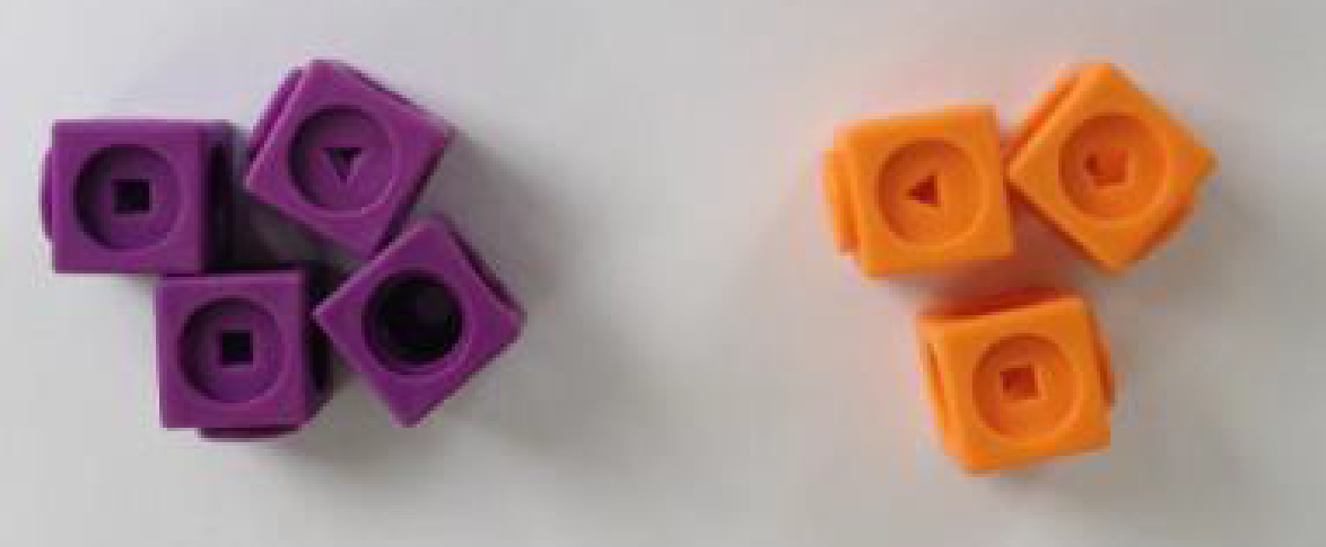  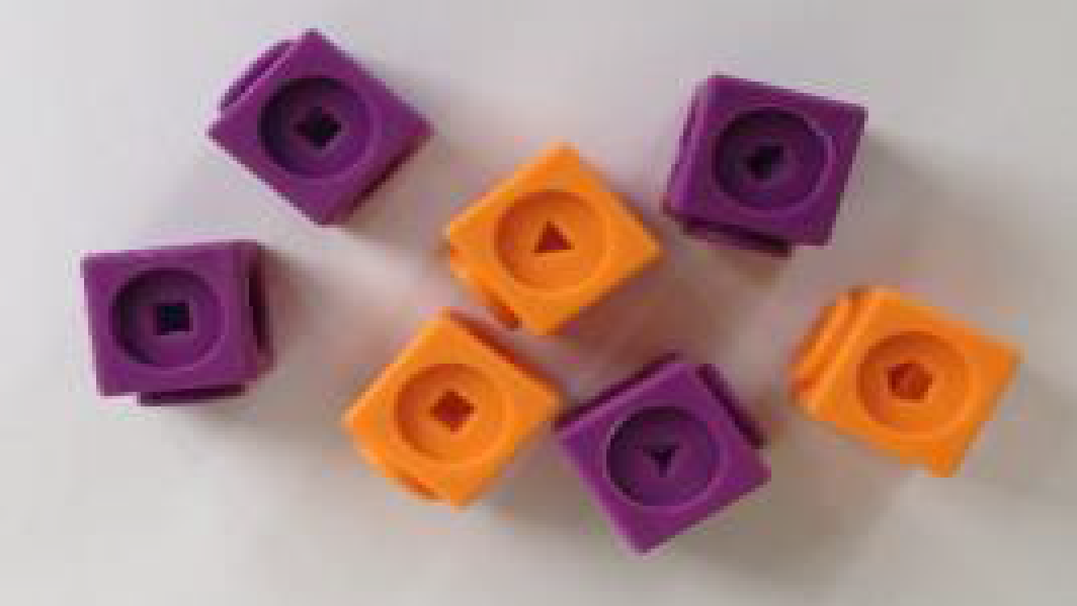  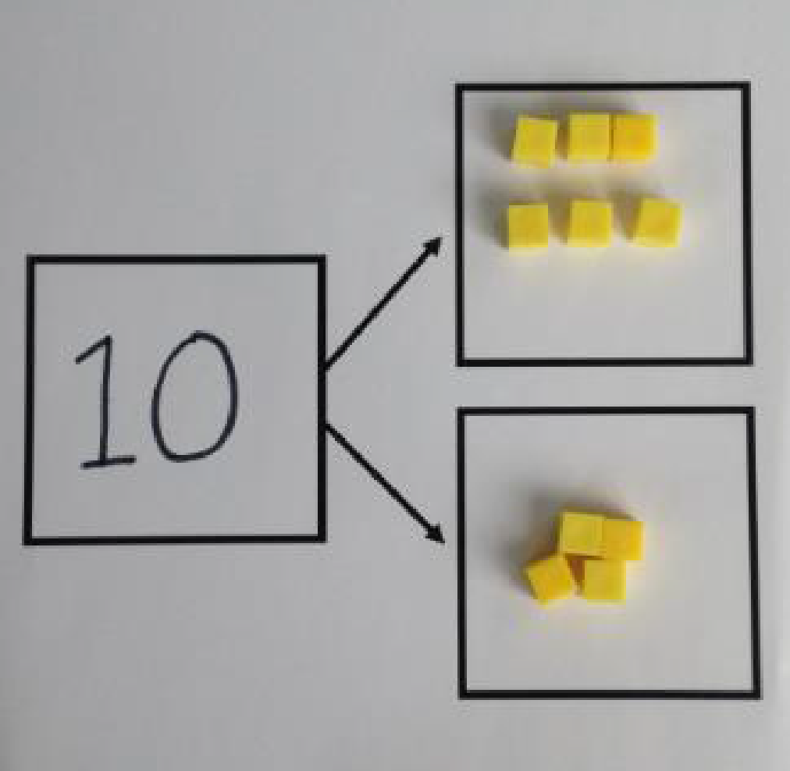  Use cubes to add two numbers together as a group or in a bar.  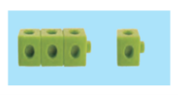  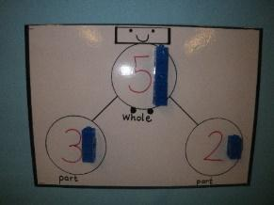  The part - part - whole model and using cubes to show this. Represent this in a variety of ways.  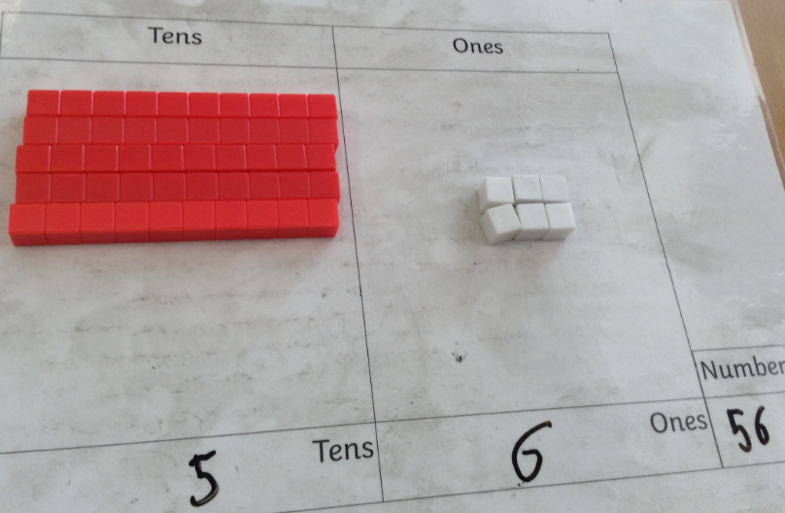  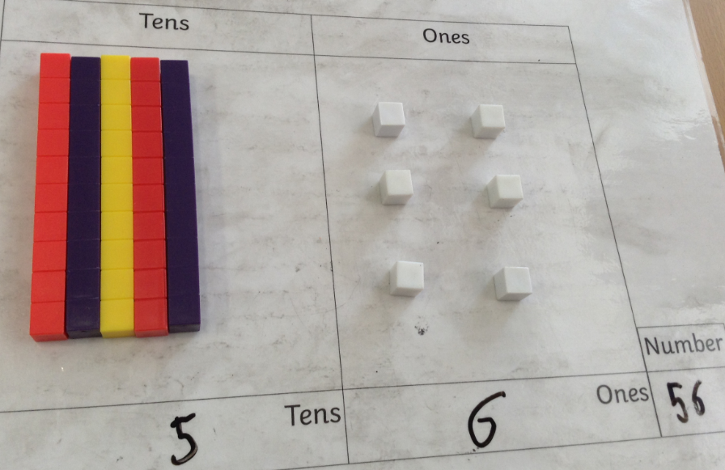  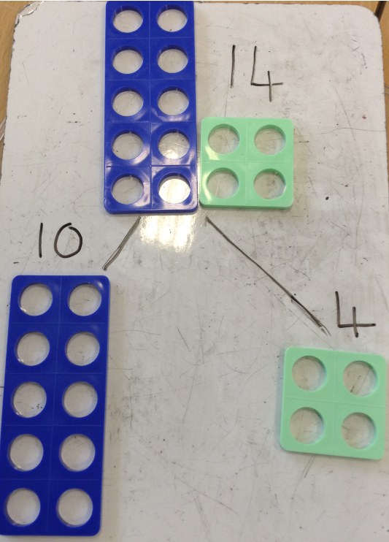 | 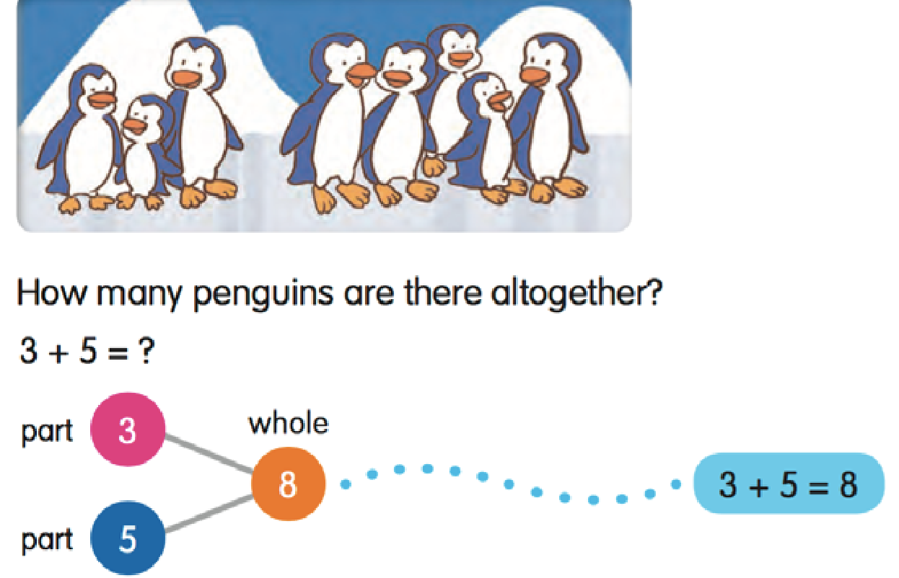  Represent this in a variety of ways  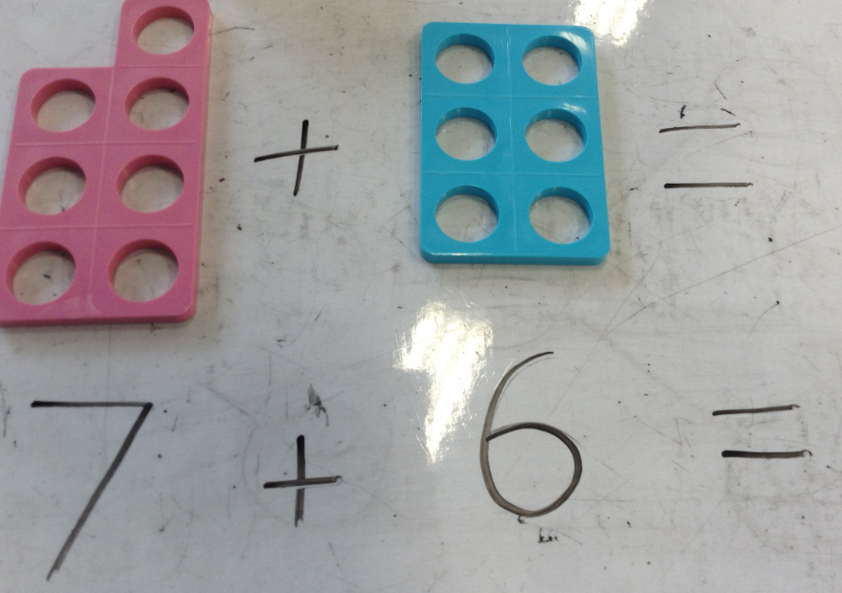  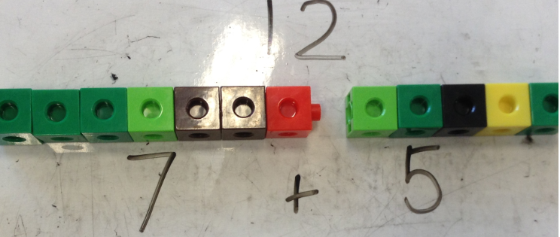  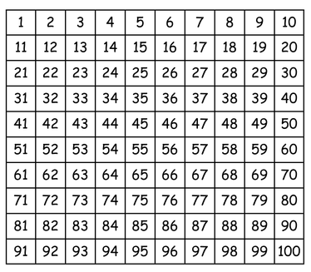 | 4 + 3 = 7  10= 6 + 4  5  3  Use the part-part whole diagram as shown above to move into the abstract.  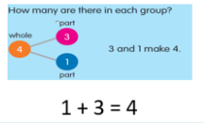
Starting at the bigger number and counting on | 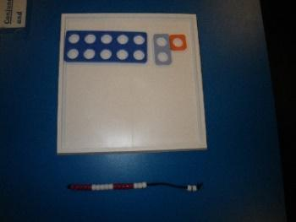  Use numicon or bead strings to put the bigger number there already encourage that the children recognise that this is 10 and not counting it.  Count on using objects.  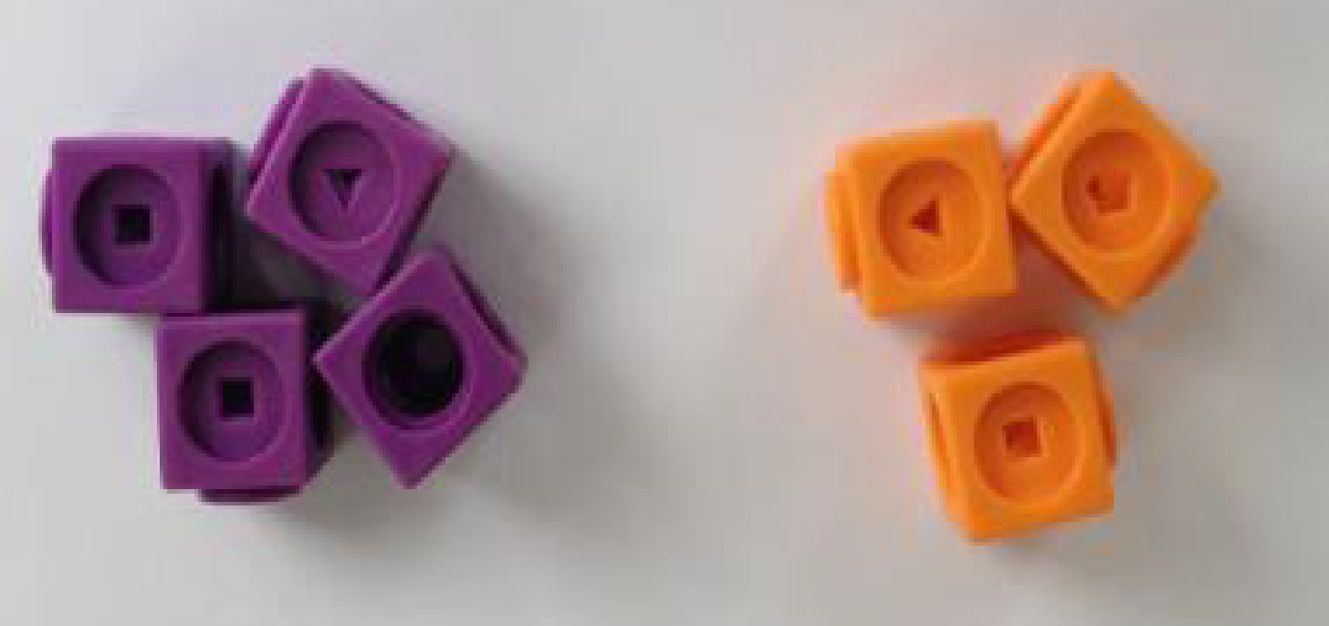 | 12 + 5 = 17  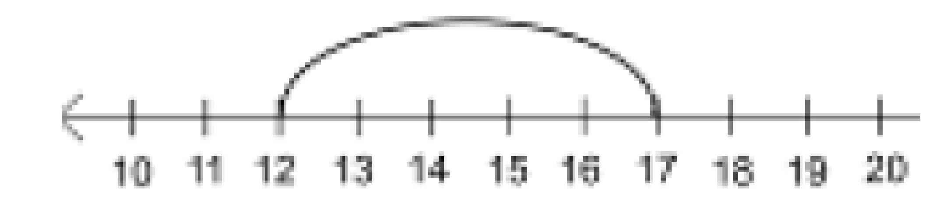  Start at the larger number on the number line and count on in ones or in one jump to find the answer.  7 + 2 = 9  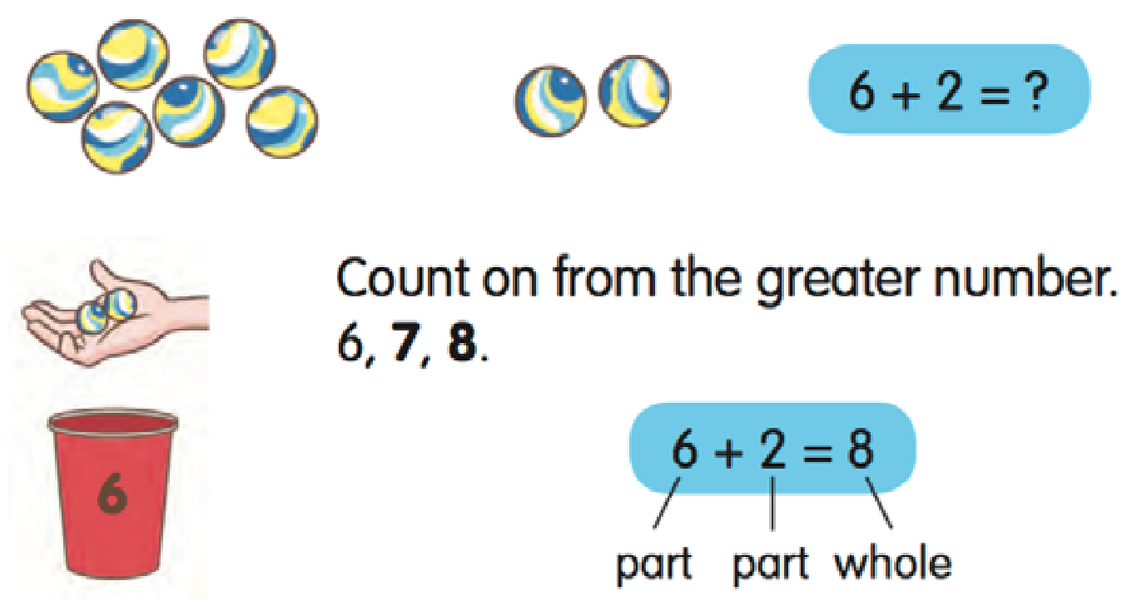  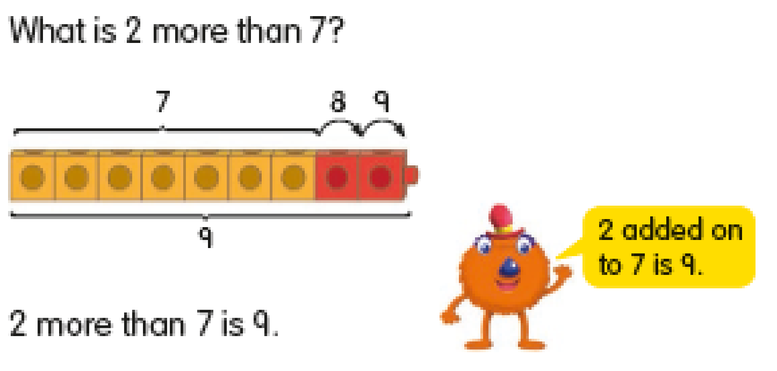 | 5 + 12 = 17  Place the larger number in your head and count on the smaller number to find your answer.
Regrouping to make 10 | 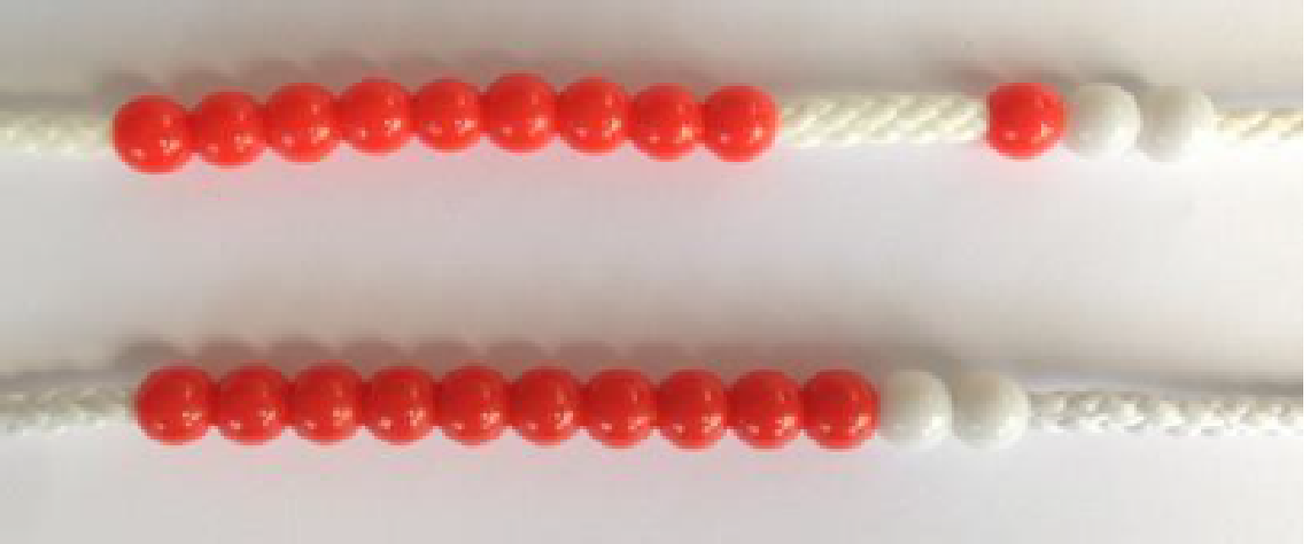  6 + 5 = 11  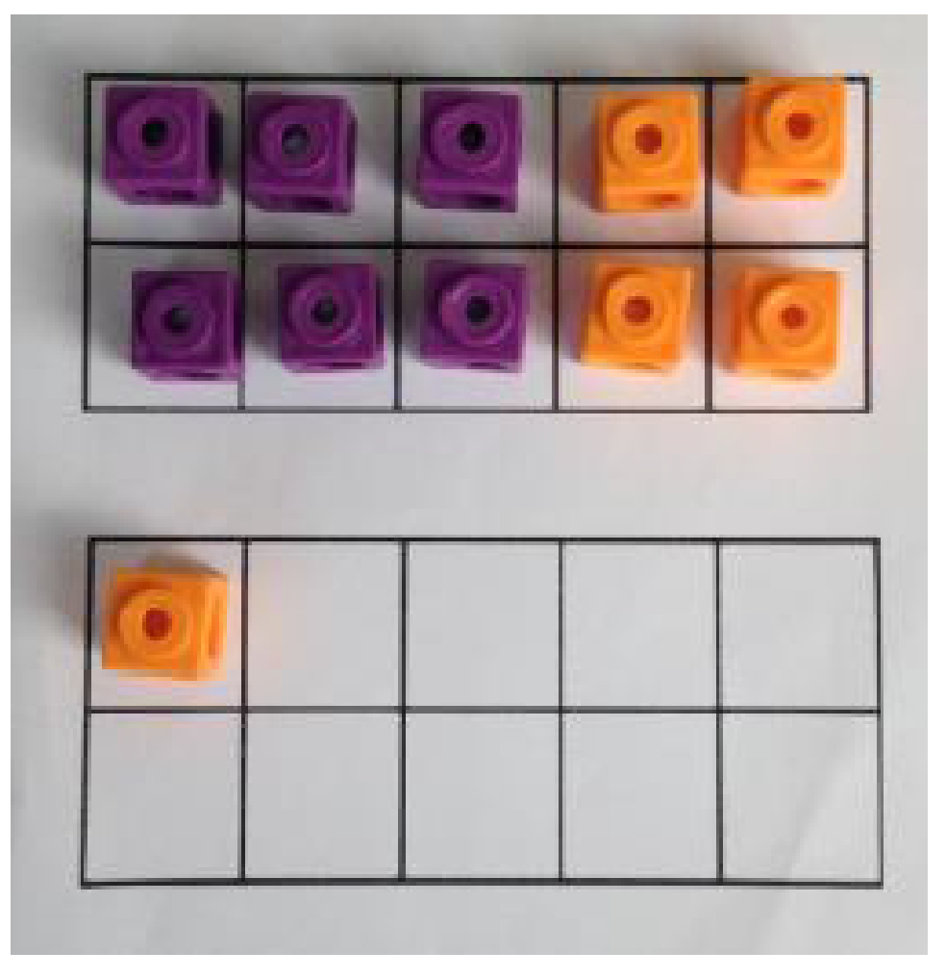  Start with the bigger number and use the smaller number to make 10.  Start with the bigger number and use the smaller number to make 10.  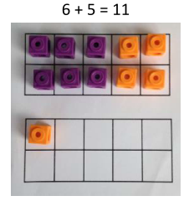  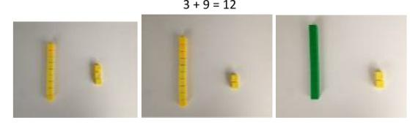  This can also be shown with Numicon resources. | 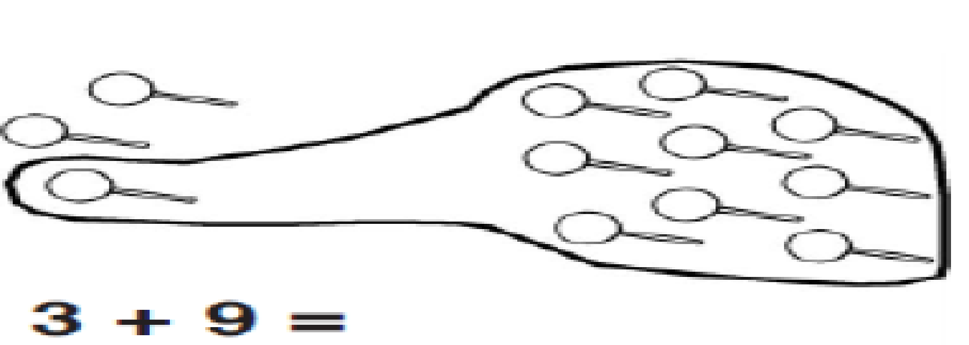  Use pictures or a number line. Regroup or partition the smaller number to make 10.  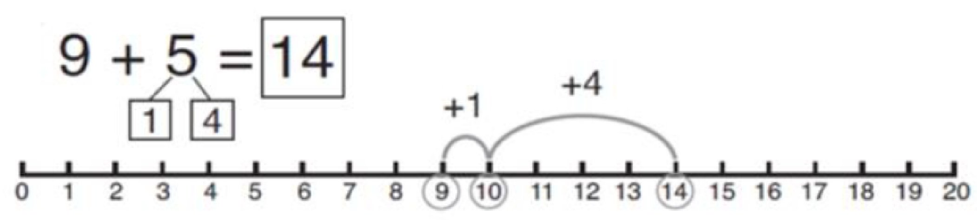  Regroup or partition the smaller number to make 10.  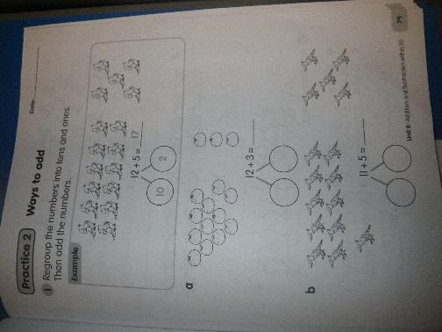 | 6 + ? = 13  How many more do I need to make 13?  7 + 4= 11  If I am at seven, how many more do I need to make 10. How many more do I add on now?
Adding three single digits | 4 + 7 + 6= 17  Put 4 and 6 together to make 10. Add on 7.  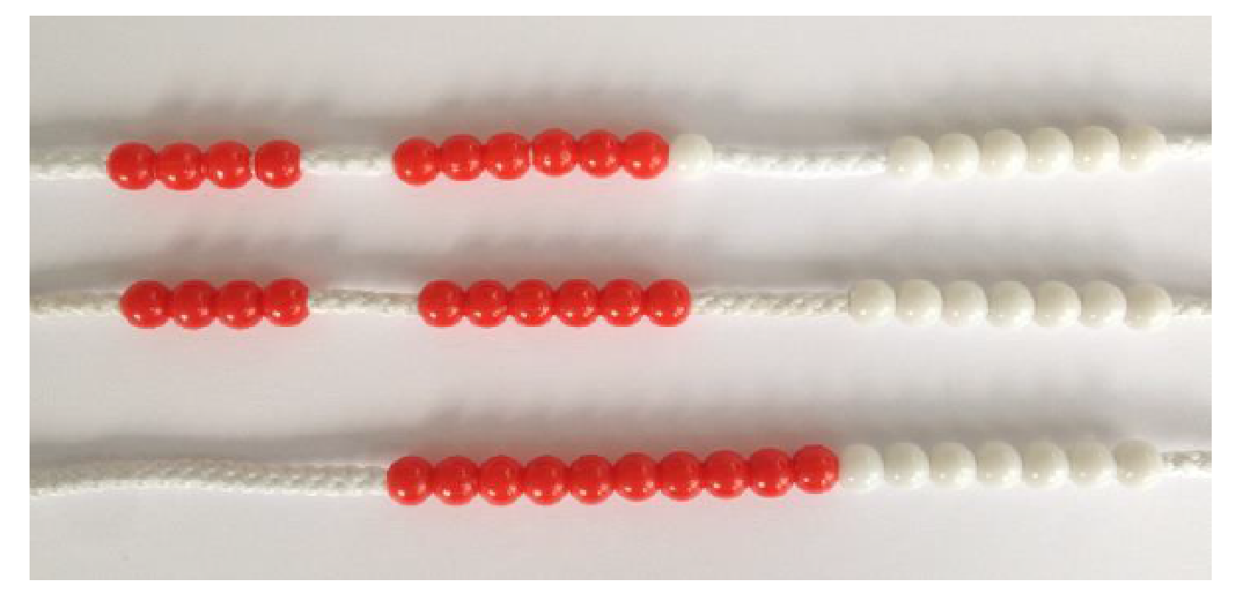  Following on from making 10, make 10 with 2 of the digits (if possible) then add on the third digit.  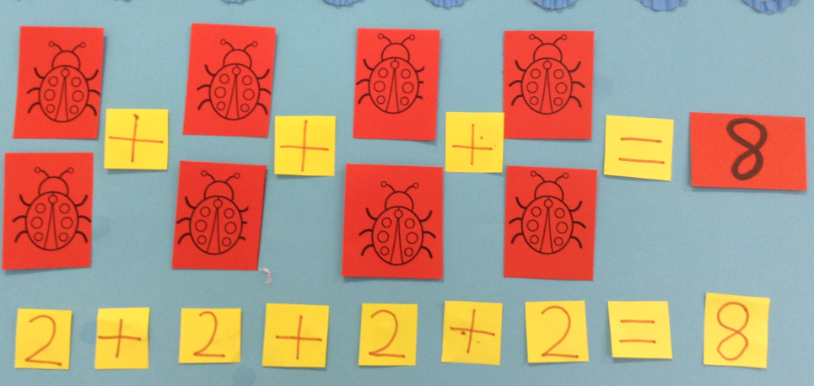  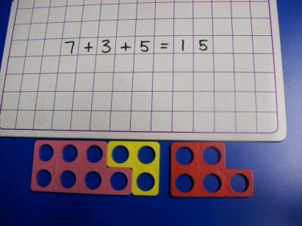 | +  +  +  Add together three groups of objects. Draw a picture to recombine the groups to make 10.  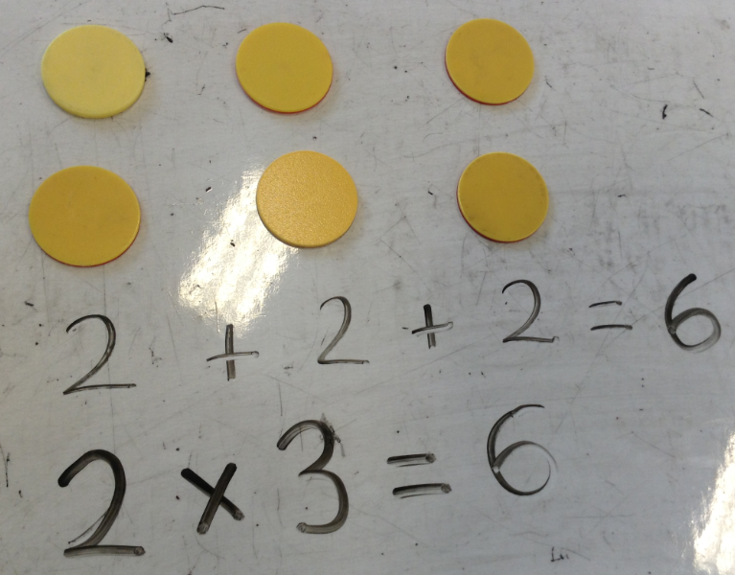 | 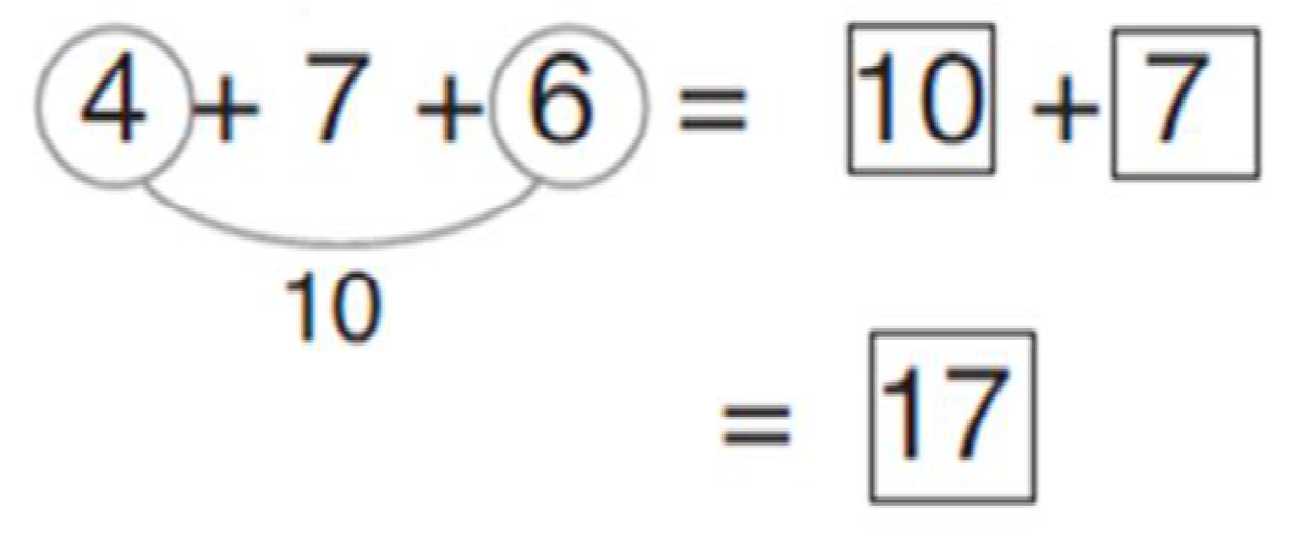  Combine the two numbers that make 10 and then add on the remainder.
Column method- no regrouping | Use dienes to add the ones first and then the tens.  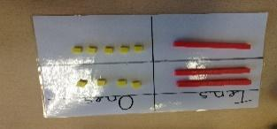  24 + 15=  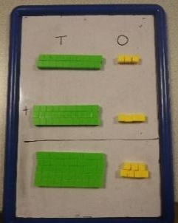  Move into hundreds  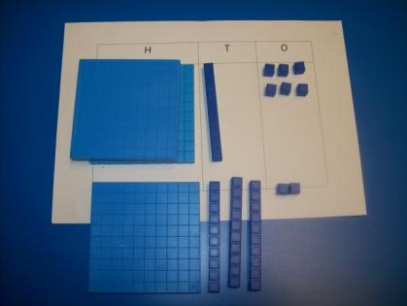  Show the abstract setting out alongside this – model this as a class.  362 + 131 =  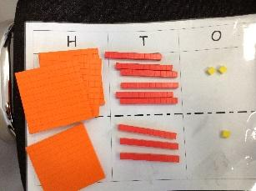  Move onto place value counters if appropriate.  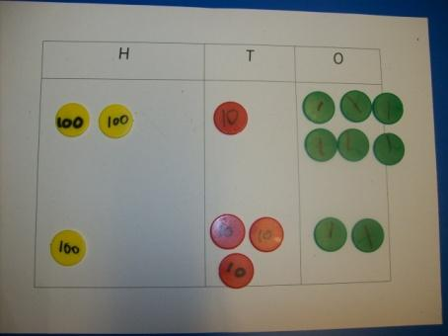  Show the abstract setting out alongside this – model this as a class. | After practically using the dienes and place value counters, children can draw the dienes or counters to help them to solve additions.  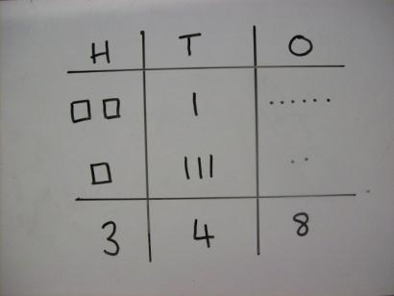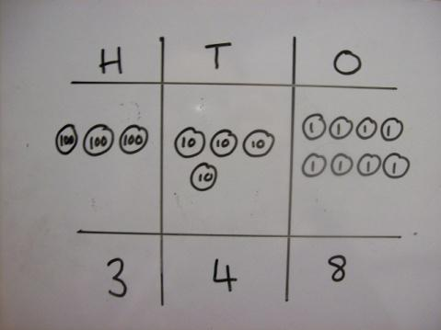  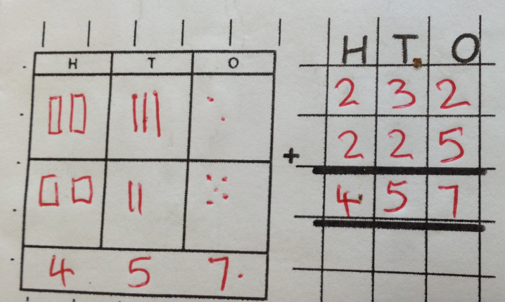  Show the abstract setting out alongside this – model this as a class. | Children complete the calculations written using the column method.
Column method- regrouping | Make both numbers on a place value grid  Add up the ones and exchange 10 ones for one 10.  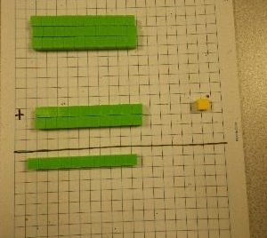  Regroup in the tens column  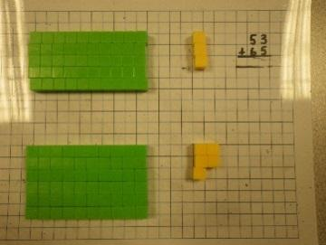  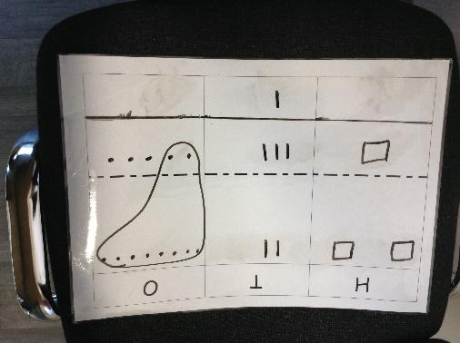  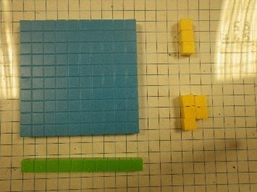  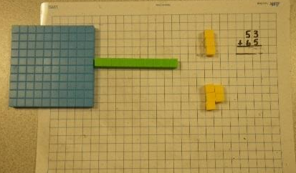  Regroup in hundreds column  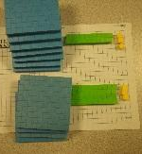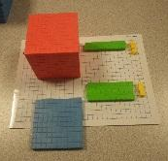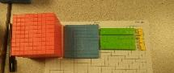  Move progressively to being able to regroup in all columns.  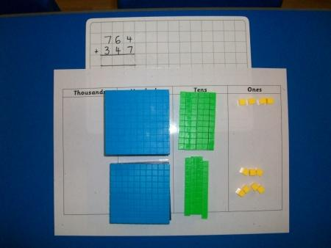  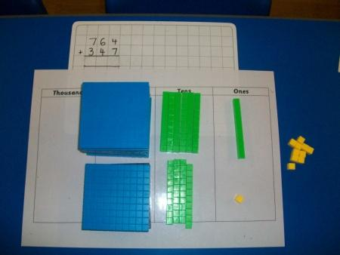  This can also be done with place value counters when children are ready.  As children move on to decimals, money and decimal place value counters can be used to support learning. | Children can draw a pictoral representation of the columns and dienes to further support their learning and understanding.  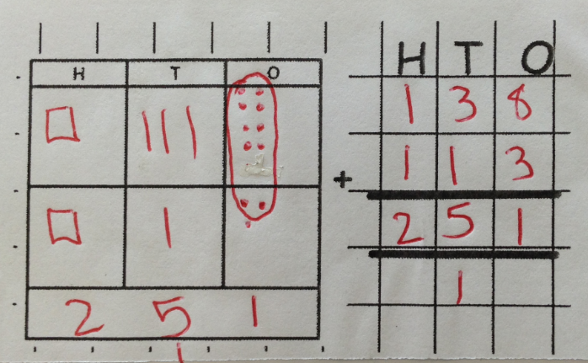  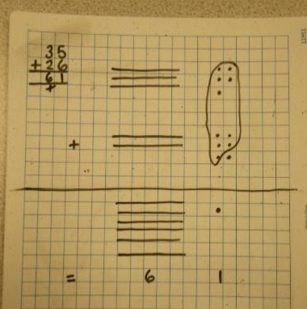  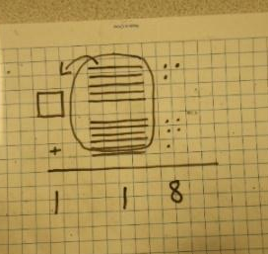  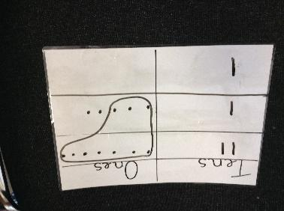 | 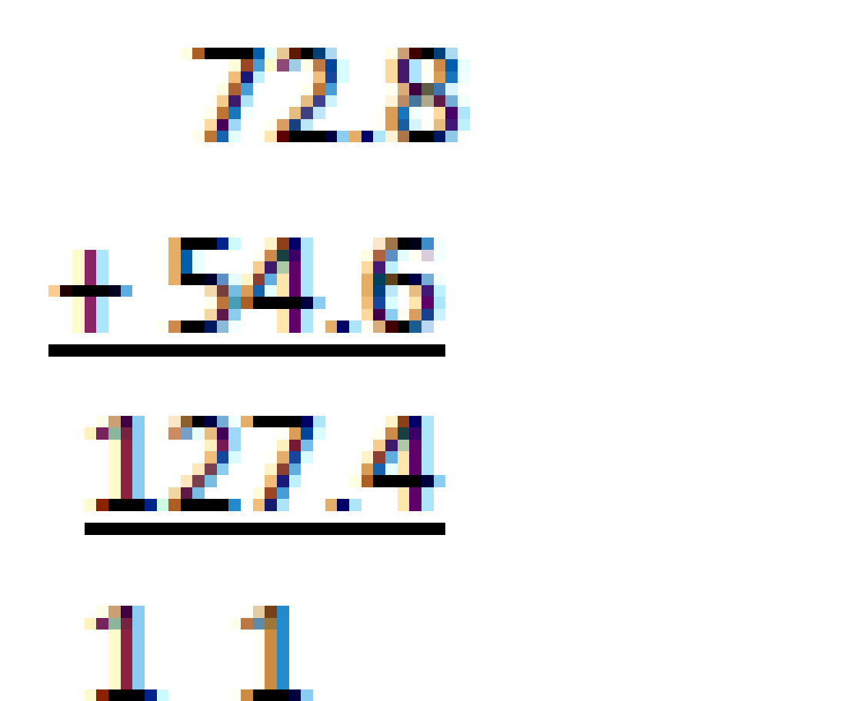  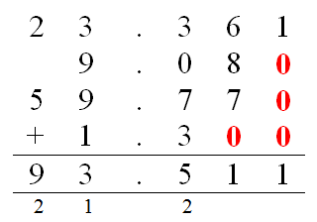  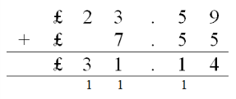  As the children move on, introduce decimals with the same number of decimal places and different. Money can be used here.

Subtraction
 | Taking away ones |  |  |  | Use physical objects, counters, cubes etc. to show how objects can be taken away  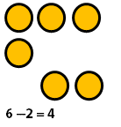  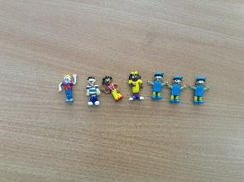 |  |  | Cross out drawn objects to show what has been taken away  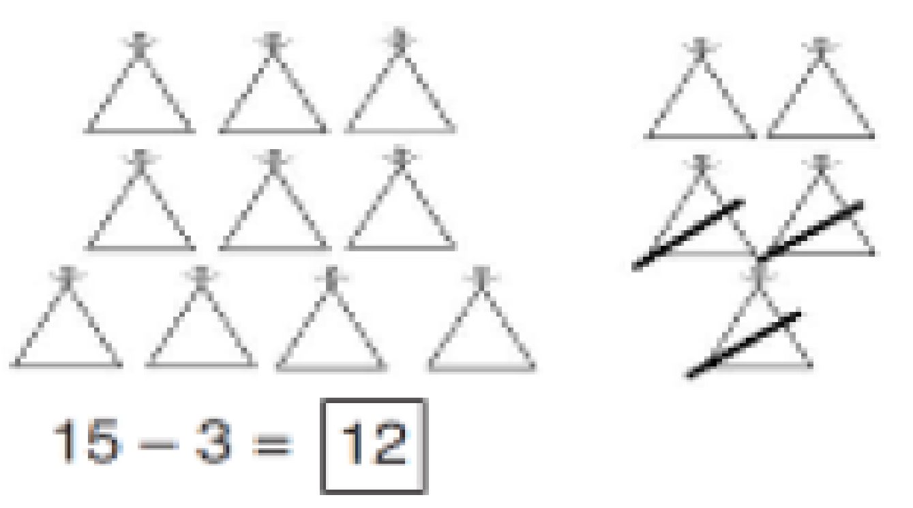  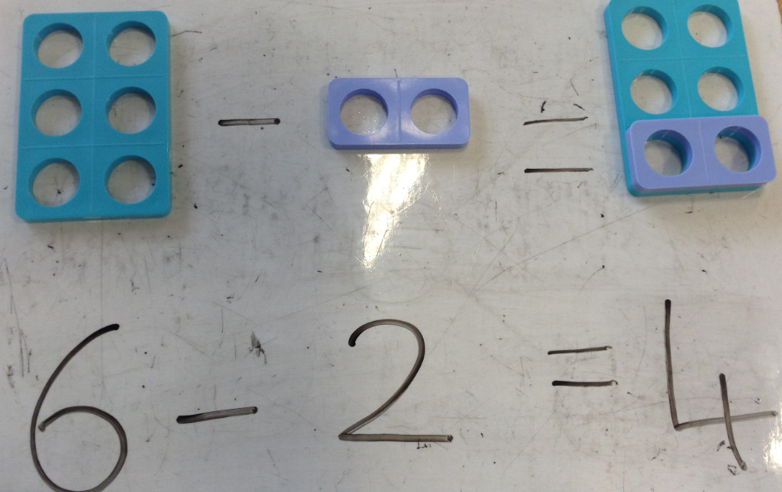 |  | 18 - 3= 15  8 – 2 = 6  Scaffold children to record their knowledge through number sentences with empty boxes.  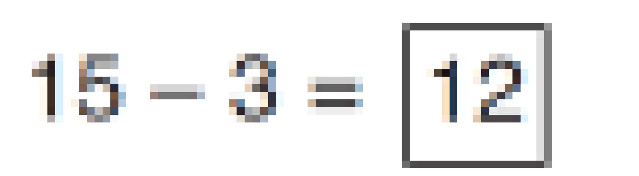
Counting back |  |  |  | Make the larger number in your subtraction. Move the beads along your bead string as you count backwards in ones.  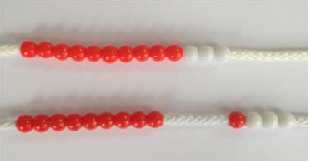  13 – 4  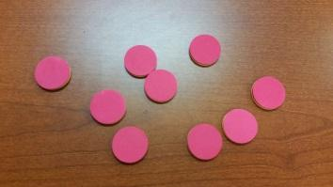  Use counters and move them away from the group as you take them away counting backwards as you go. |  |  | Count back on a number line or number track  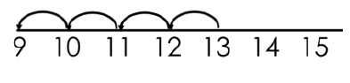  Start at the bigger number and count back the smaller number showing the jumps on the number line.  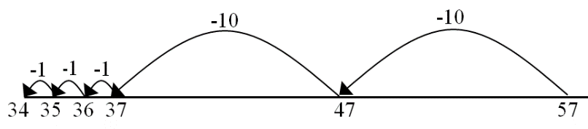  This can progress all the way to counting back using two 2-digit numbers. |  | Put 13 in your head, count back 4. What number are you at? 13 – 4 = □  Abstract notation of number sentences. Include the use of missing boxes and the missing box in different places:  26 – 13 = □  □ – 16 = 12  18 - □ = 7
Find the difference |  |  |  | 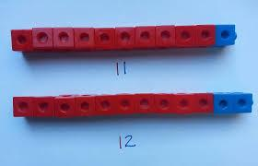  Compare amounts and objects to find the difference.  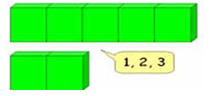  Use Numicon to show the difference.  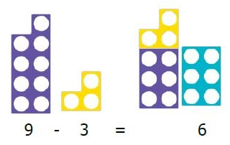 |  |  | Count on to find the difference. Draw bars to find the difference between 2 numbers.  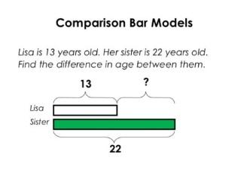  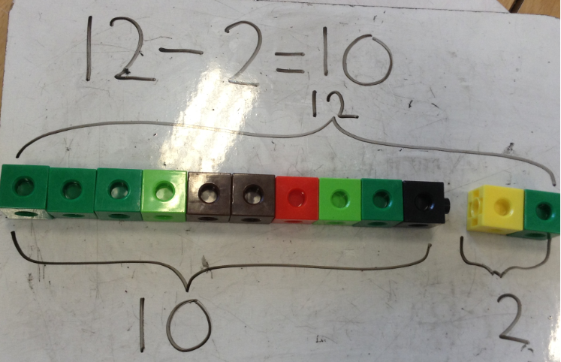 |  | Abstract notation of number sentences. Include the use of missing boxes and the missing box in different places:  26 – 13 = □  □ – 16 = 12  18 - □ = 7  Hannah has 23 sandwiches, Helen has 15 sandwiches. Find the difference between the number of sandwiches.
Part Part Whole Model |  |  |  | 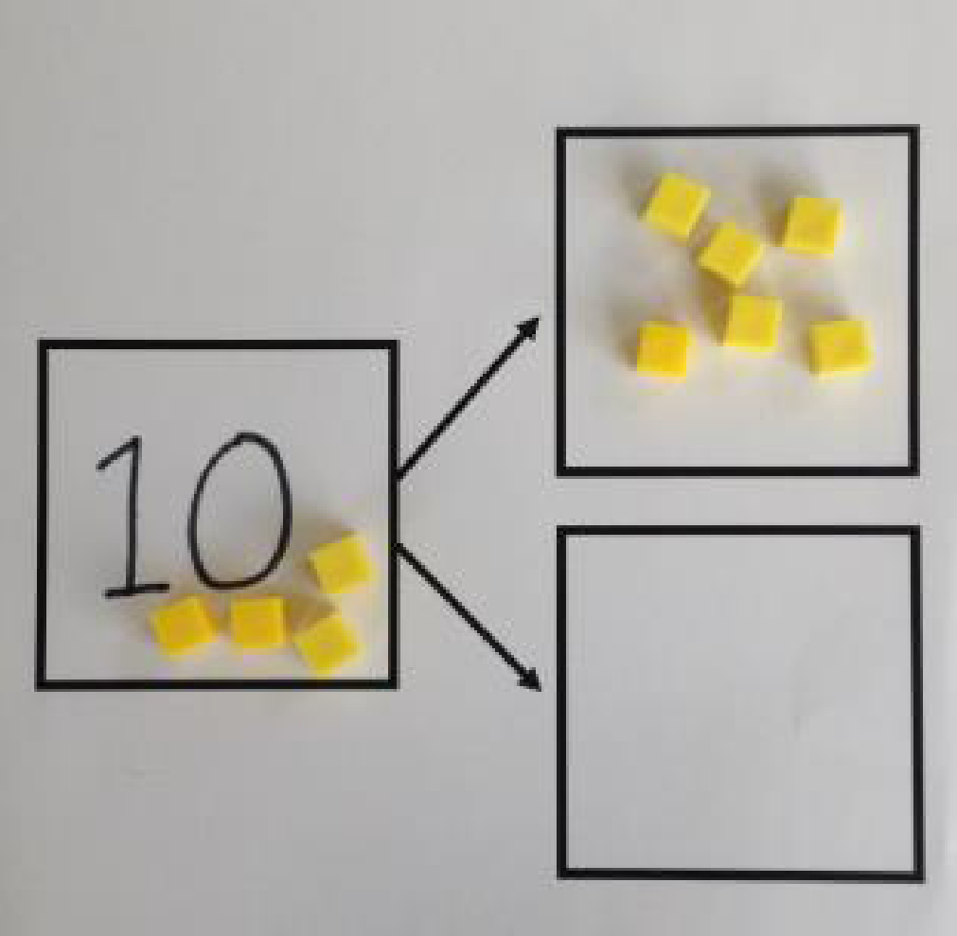  Link to addition through the use of the PART-WHOLE model to help explain the inverse between addition and subtraction.  10 – 6 = □  If 10 is the WHOLE and 6 is one of the PARTS. What is the other PART? |  |  | Use a pictorial representation of objects to show the PART-PART-WHOLE model.  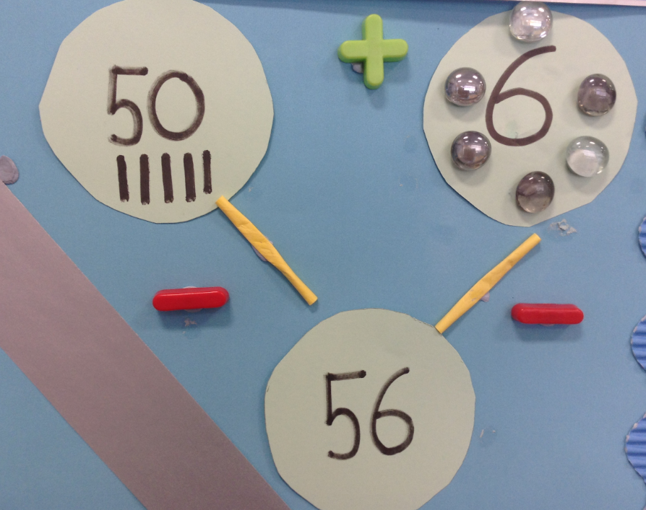 |  | Move to using numbers within the part whole model.  10  5
Make 10 |  |  |  | 14 – 9 = □  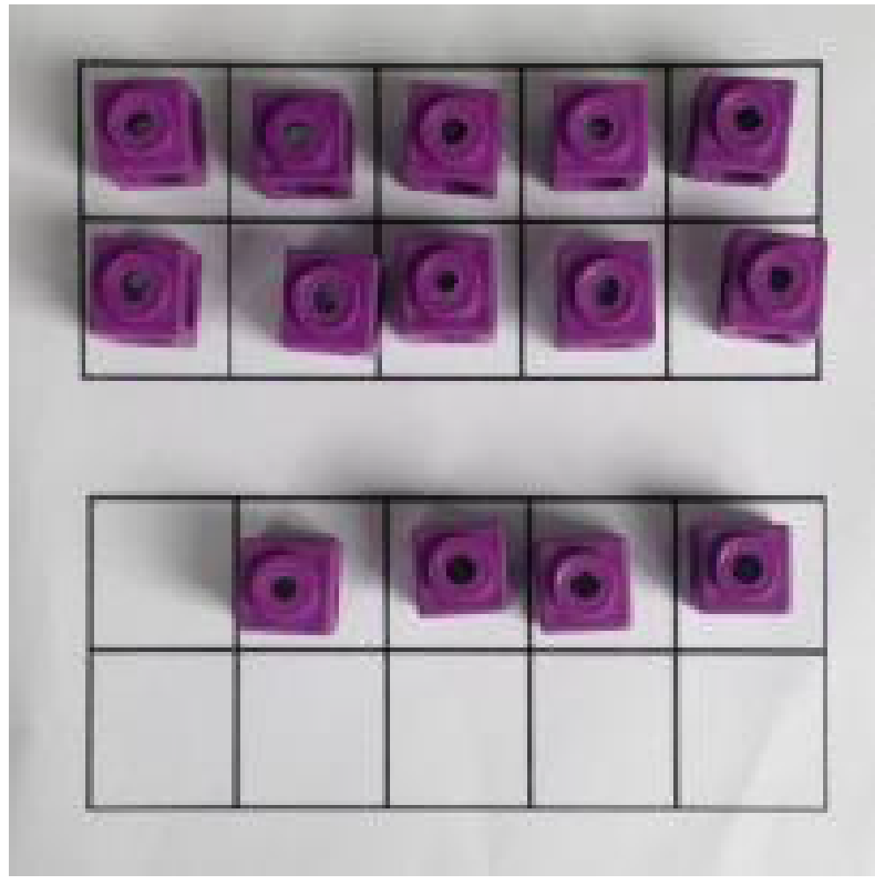  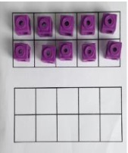  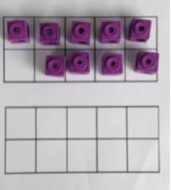  Make 14 on the ten frame.  Take away the four first to make 10  Then takeaway one more so you have taken away 5.  You are left with the answer of 9.  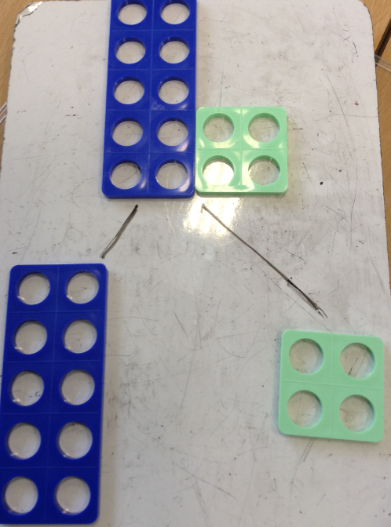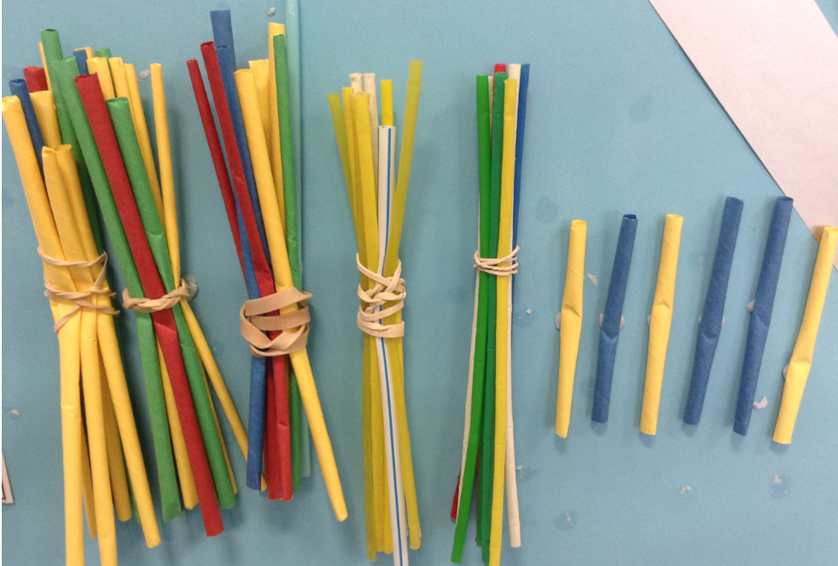  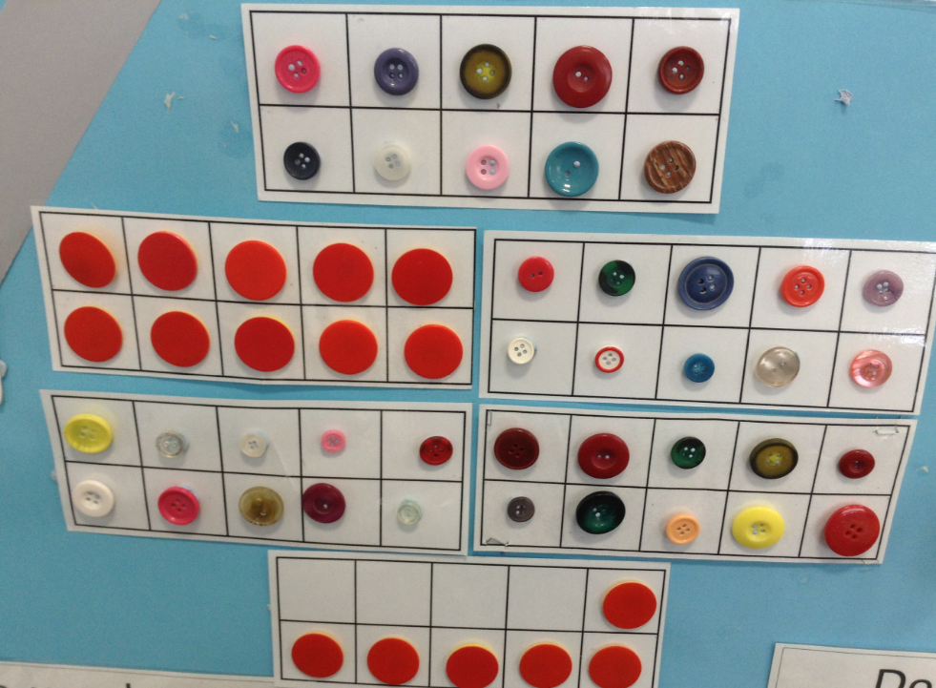 |  |  | 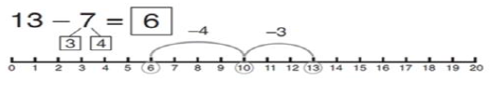  Start at 13.  Take away 3 to reach 10.  Then take away the remaining 4 so you have taken away 7 altogether.  You have reached your answer. |  | 16 – 8 = □  How many do we take off to reach the next 10?  How many do we have left to take off?  Abstract notation of number sentences. Include the use of missing boxes and the missing box in different places:  26 – 13 = □  □ – 16 = 12  18 - □ = 7  Missing box calculations will also provide an additional scaffold for pupils to begin their abstract recording.
Column method without regrouping |  |  |  | Make the number then take away the number from the ones, tens and hundreds  Follow the same process for hundreds, tens and ones and thousands, hundreds, tens and ones.  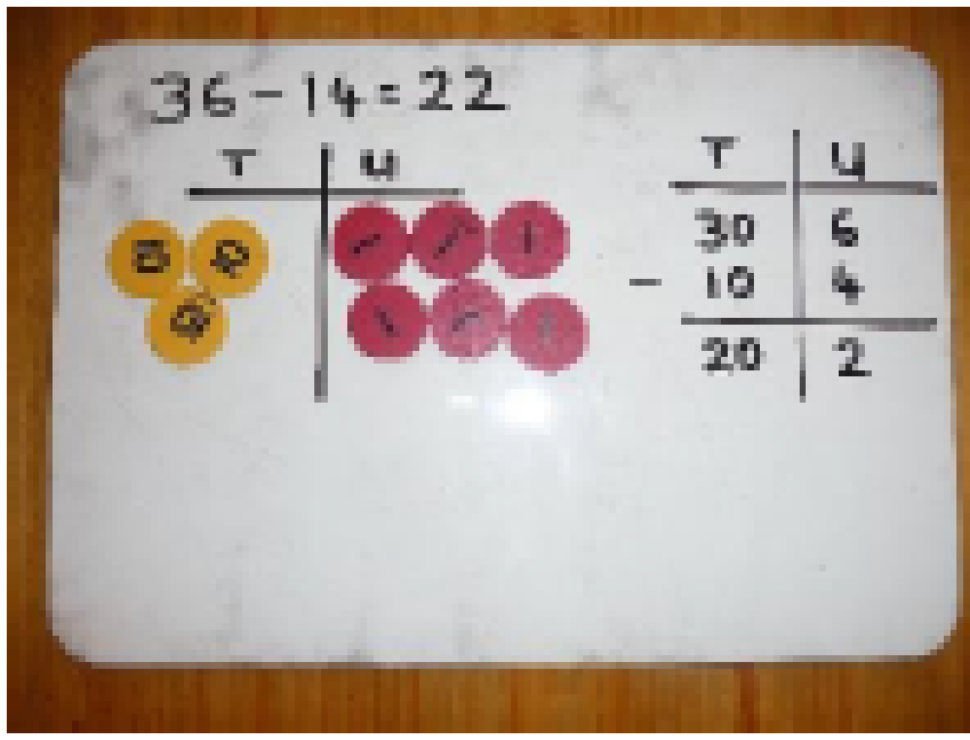  Show how you partition numbers to subtract. Again make the larger number first. |  |  | Draw the dienes or place value counters alongside the written calculation to help to show working.  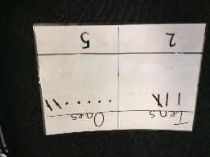  First draw the biggest number. Cross out the ones and then cross out the tens.  37 – 12 =  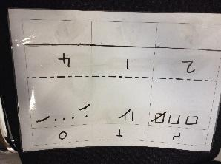  326 – 112 =  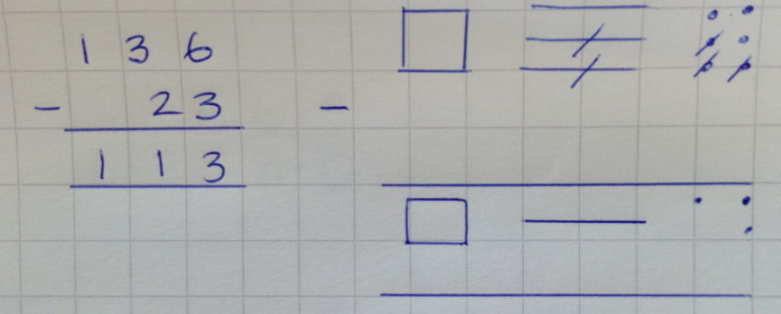  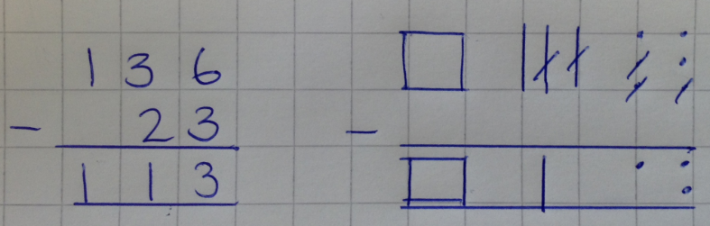
Column method with regrouping |  |  |  | Use dienes to start with before moving on to place value counters. Start with one exchange before moving onto subtractions with 2 exchanges.  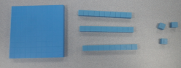  Set out the larger number and take the number away  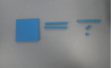  Once you have regrouped in the ones, tens, or hundreds then you can physically take away the number.  Make the larger number with the place value counters  Start with the ones, can I take away 8 from 4 easily? I need to exchange one of my tens for ten ones.  Now I can subtract my ones.  Now look at the tens, can I take away 8 tens easily? I need to exchange one hundred for ten tens.  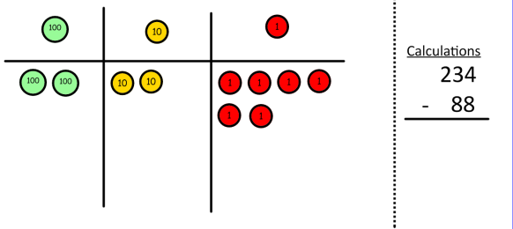  Now I can take away eight tens and complete my subtraction  Show children how the concrete method links to the written method alongside your working. Cross out the numbers when exchanging and show where we write our new amount. |  |  | 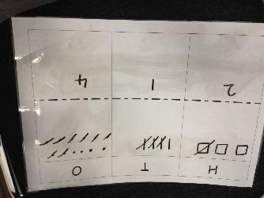  Draw the dienes or place value counters onto a place value grid and show what you have taken away by crossing the counters out as well as clearly showing the exchanges you make.  342 – 128 =  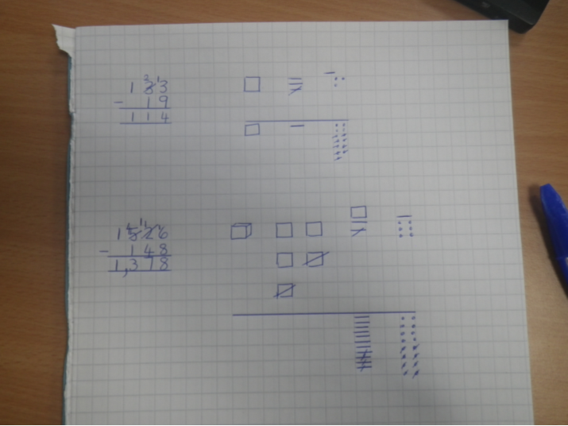 |  | 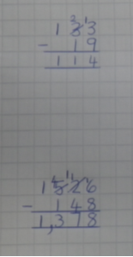  This can then be moved onto regrouping in all columns.  The children can then apply this method to much larger numbers and decimals.
Multiplication
Doubling |  | 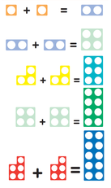  Use practical activities to show how to double and halve number.  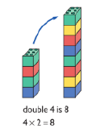  Numicon  Dice  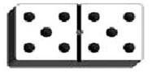  Domino |  |  |  | Draw pictures to show how to double and halve a number.  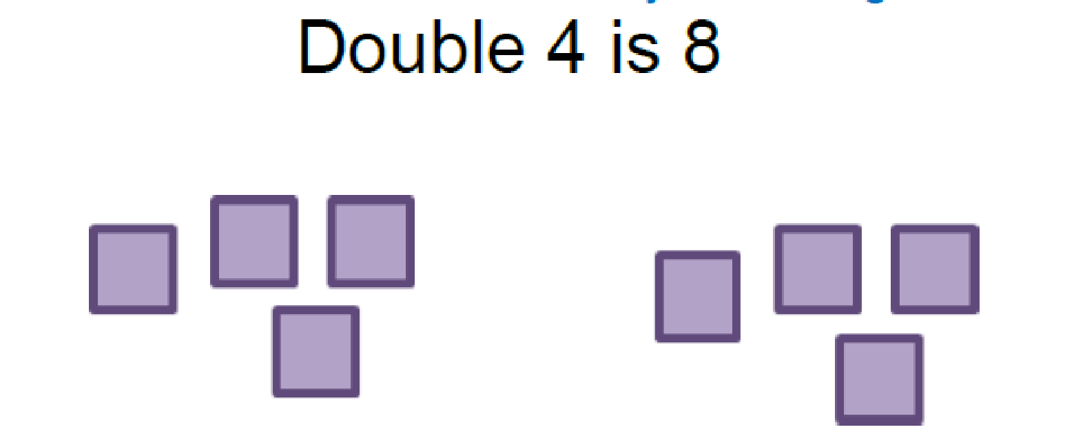  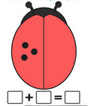 |  |  |  |  | Partition a number and then double each part before recombining it back together.  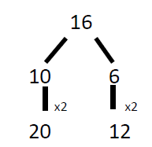  Link doubles to addition double number sentences.  Partition a number, and then halve each part before recombining it back together (as doubling example above).
Counting in multiples |  | Count in multiples supported by concrete objects in equal groups. Skip counting.  Four groups of 5: 5, 10, 15, 20  4 x 5 = 20  Four groups of 2: 2, 4, 6, 8  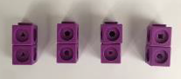  Actual fingers to support counting.  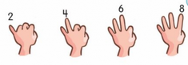  Numicon for counting in 5s and 2s and 10s.  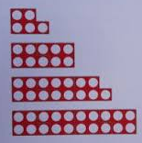  Using coins: 1p, 2, 5p & 10p. |  |  |  | Use a number line or pictures to continue support in counting in multiples.  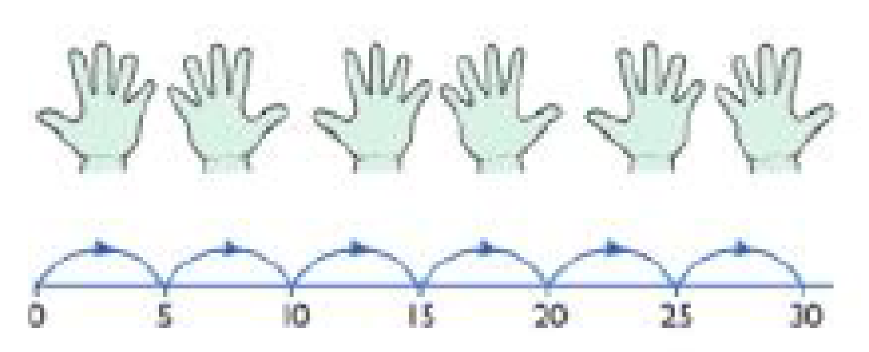  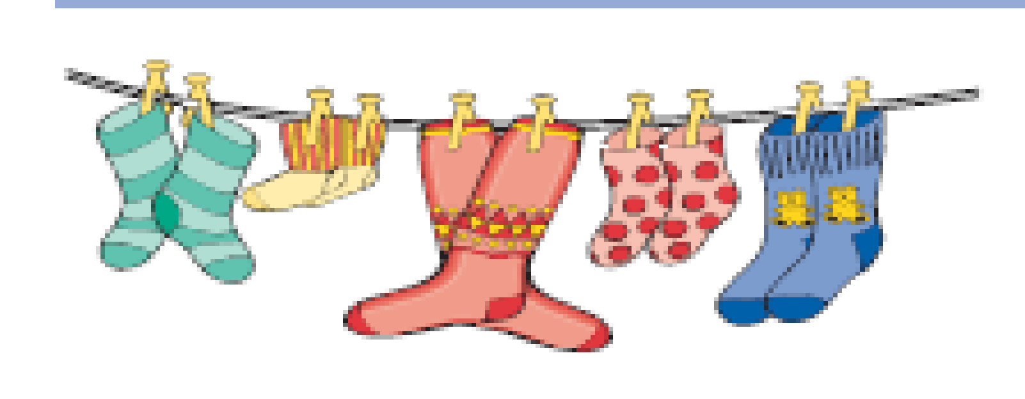 |  |  |  |  | Verbal count in multiples of a number aloud.  Write sequences with multiples of numbers (e.g. 2, 4, 6, 8, 10 or 5, 10, 15, 20, 25 , 30)  Include missing box sequences.
Repeated addition |  | Use a range of different objects, real-life and linked to the wider curriculum and mathematical equipment, to add equal groups.  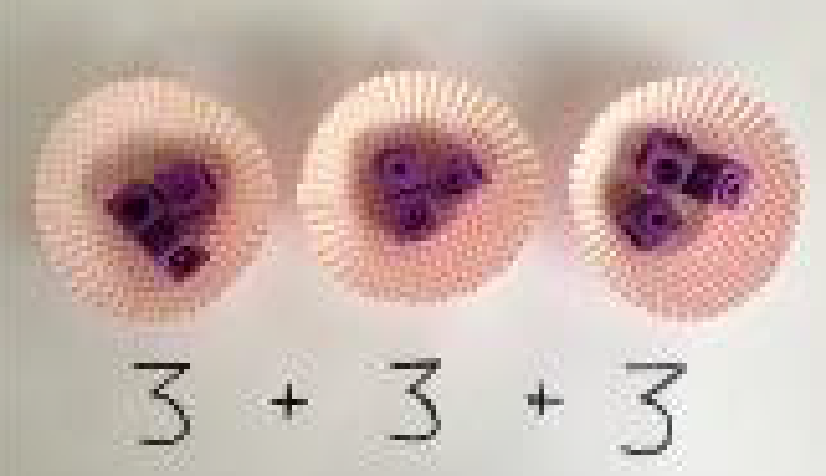  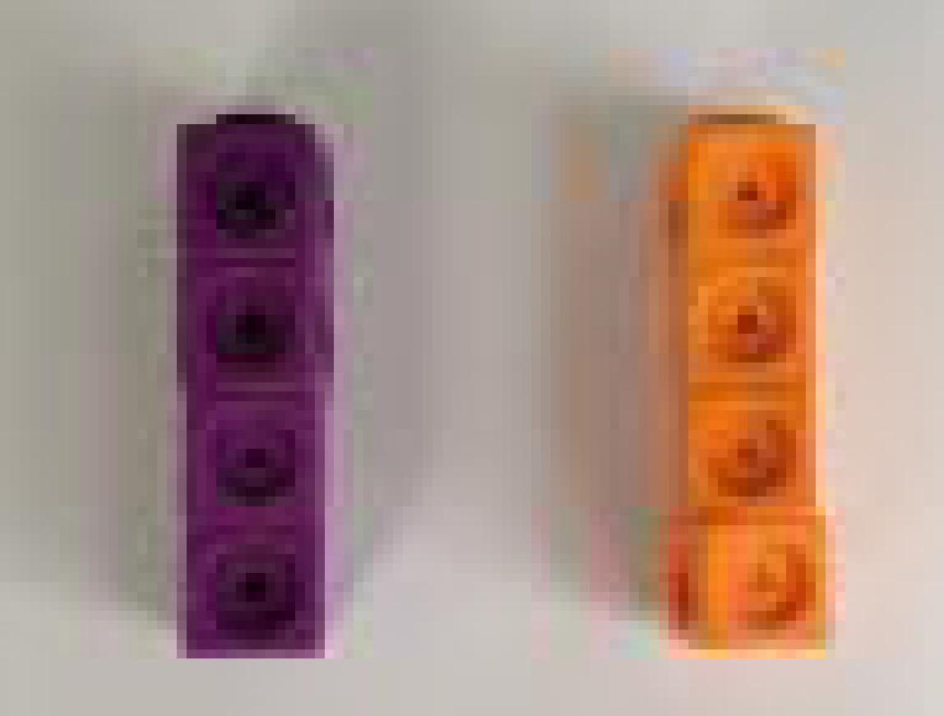 |  |  |  | 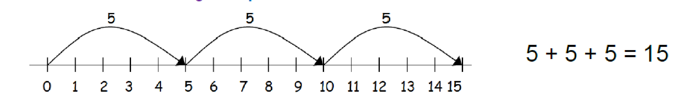  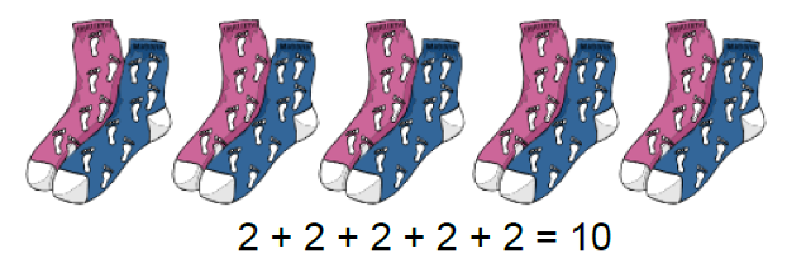  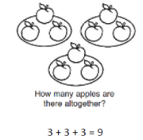  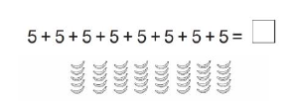  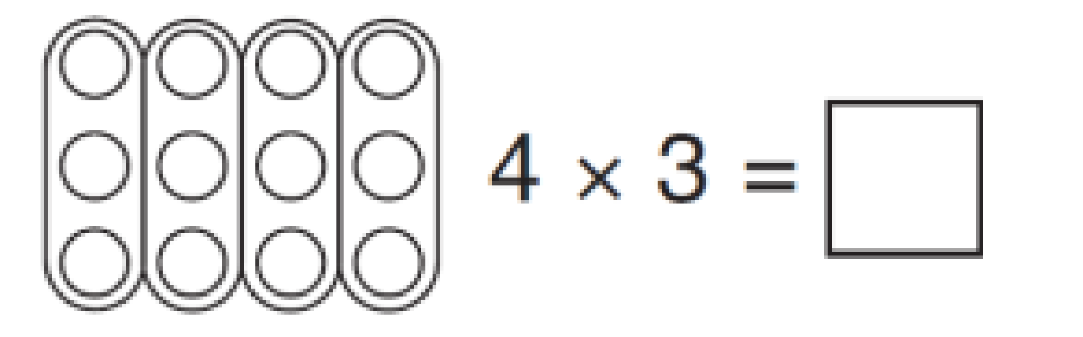  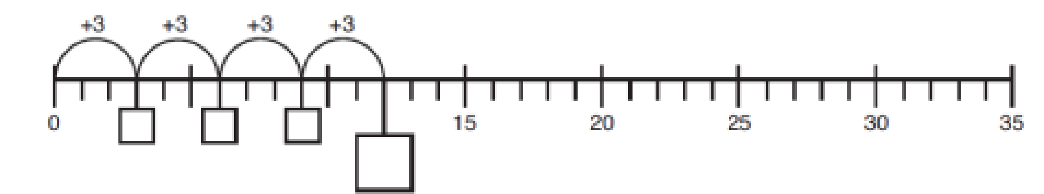 |  |  |  |  | Write number sentences to describe objects and/or pictorial representations.  2 + 2 + 2 + 2 + 2 = 10  Link repeated addition to multiplication:  2 + 2 + 2 = 6  2 x 3 = 6
Arrays- showing commutative multiplication |  | 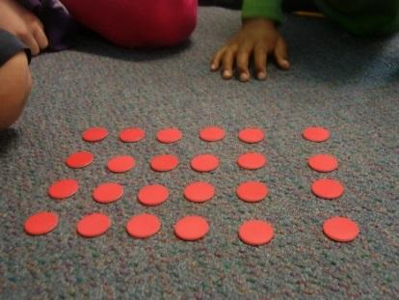  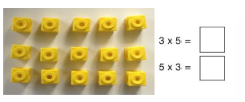  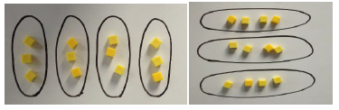  Create arrays using counters/ cubes to show multiplication sentences. |  |  |  | 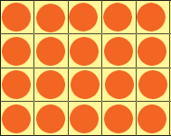  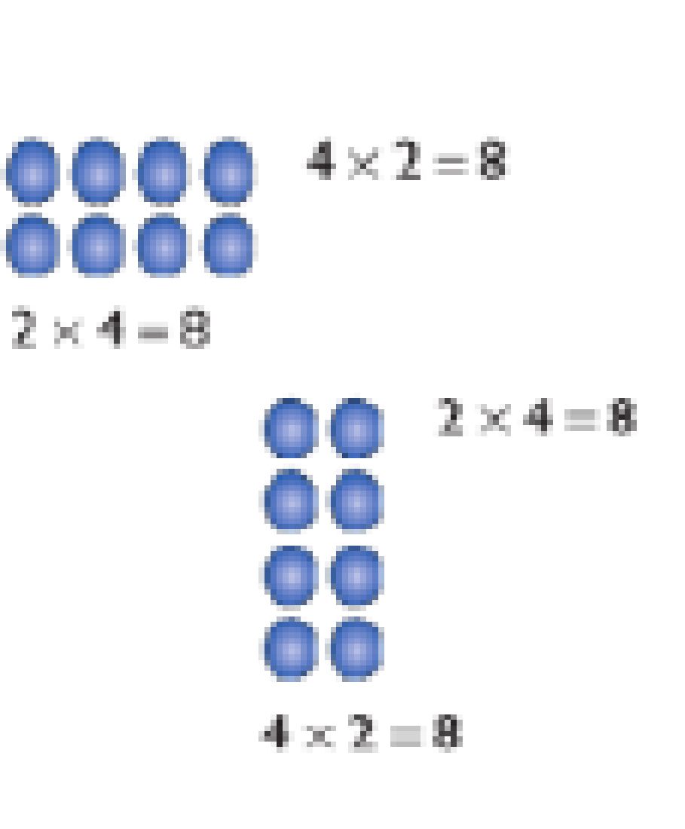  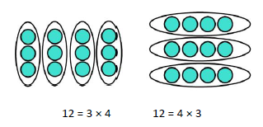  Draw arrays in different rotations to find commutative multiplication sentences. |  |  |  |  | Use an array to write multiplication sentences and reinforce repeated addition.  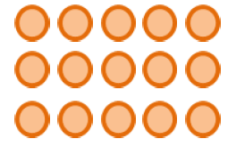  5 + 5 + 5 = 15  3 + 3 + 3 + 3 + 3 = 15  5 x 3 = 15  3 x 5 = 15
Grid method |  | Show the link with arrays to first introduce the grid method.  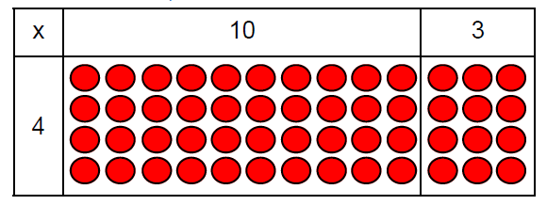  4 rows of 10  4 rows of 3  Move on to using Base 10 to move towards a more compact method.  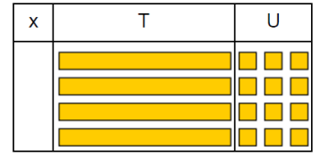  4 rows of 13  Move on to place value counters to show how we are finding groups of a number.We are multiplying by 4 so we need 4 rows.  Fill each row with 126.  Add up each column, starting with the ones making any exchanges needed.  Then you have your answer. |  |  |  | Children can represent the work they have done with place value counters in a way that they understand.  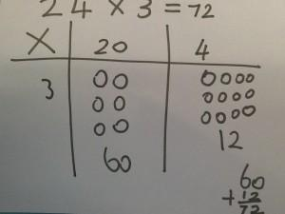  They can draw the counters, using colours to show different amounts or just use circles in the different columns to show their thinking as shown below |  |  |  |  | 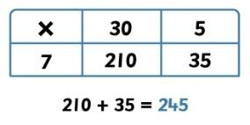  Start with multiplying by one digit numbers and showing the clear addition alongside the grid.  Moving forward, multiply by a 2 digit number showing the different rows within the grid method.  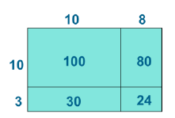  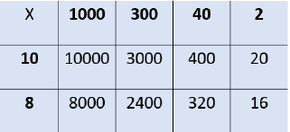
Column multiplication |  | Children can continue to be supported by place value counters at the stage of multiplication.  64 x 3 =  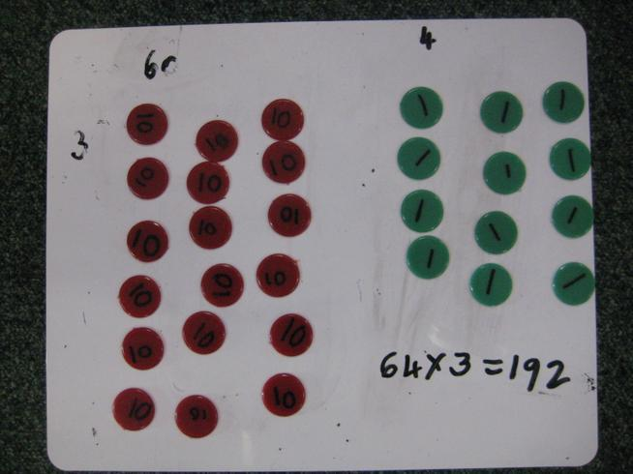  It is important at this stage that they always multiply the ones first and note down their answer followed by the tens which they note below. |  |  |  | Children could then move onto drawing the counters. |  |  |  |  | Start with long multiplication, reminding the children about lining up their numbers clearly in columns.  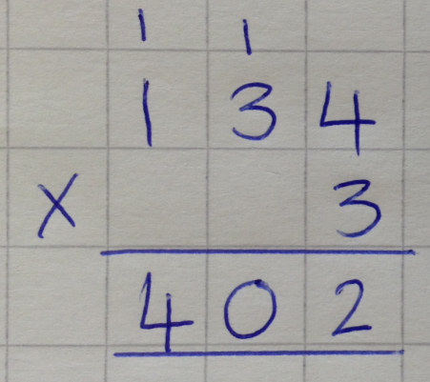  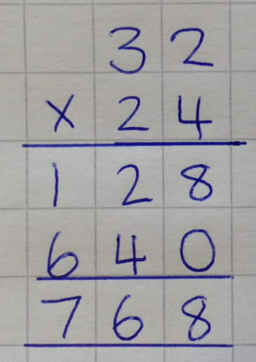  If it helps, children can write out what they are solving next to their answer.  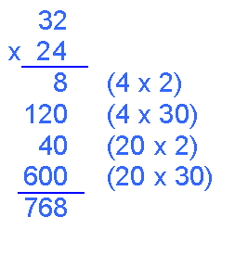  This moves to the more compact method.  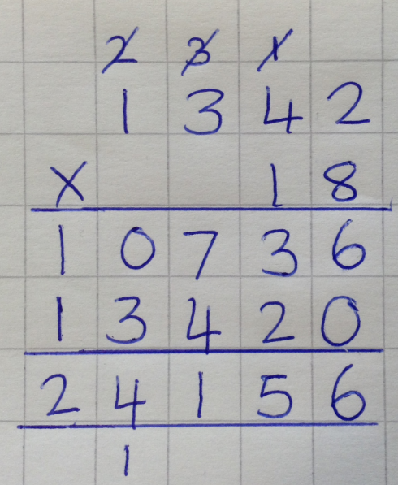
Division

Sharing objects into groups |  |  | I have 10 cubes, can you share them equally in 2 groups?  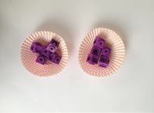  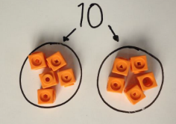 |  |  | 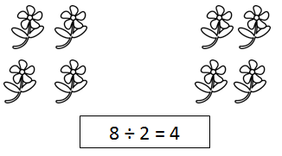  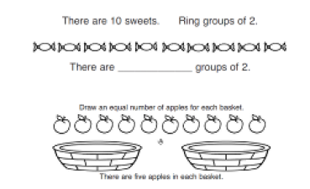  Children use pictures or shapes to share quantities.  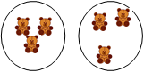  6 teddies shared into 2 hoops.  6 ÷ 2 = 3 |  |  |  |  | Share 9 buns between three people.  9 ÷ 3 = 3
Division as grouping |  |  | 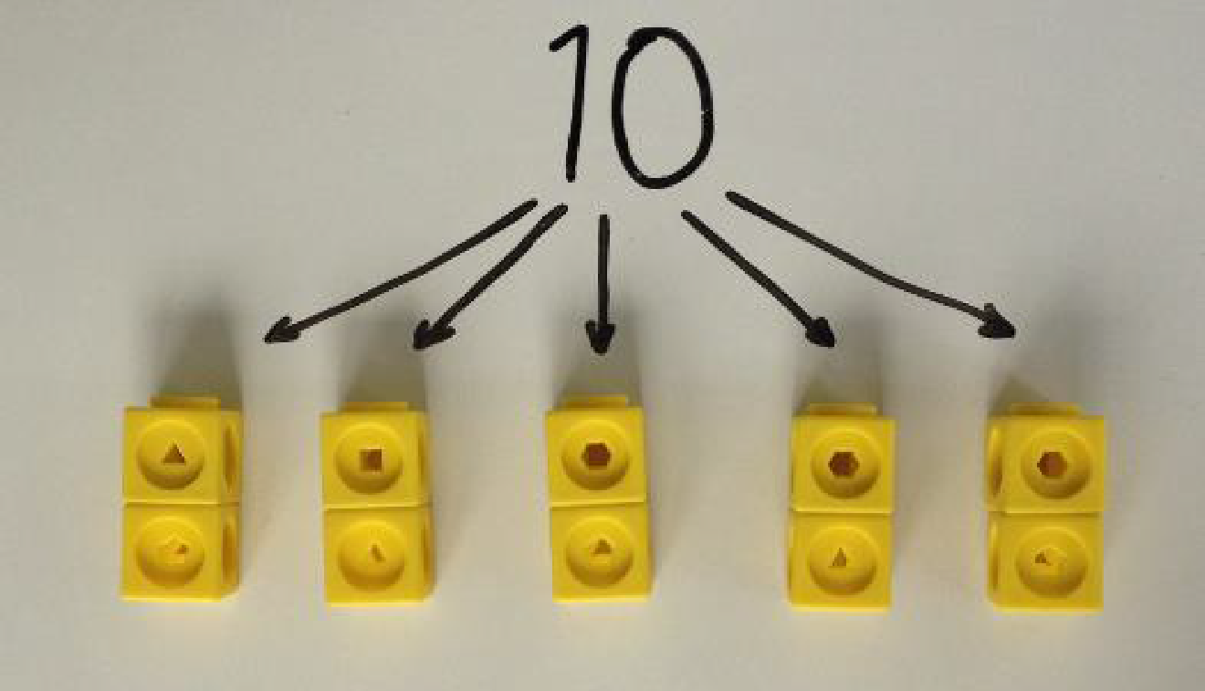  Divide quantities into equal groups.  Use cubes, counters, objects or place value counters to aid understanding or link to real-life equipment and those connected to the wider curriculum.  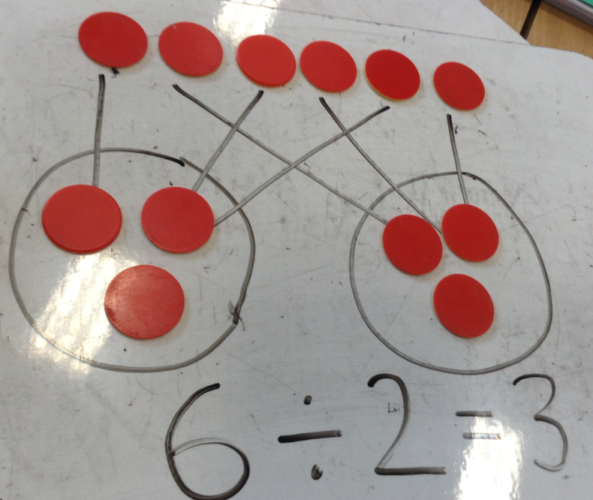  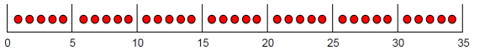  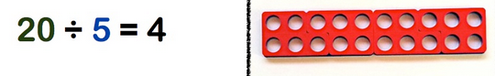  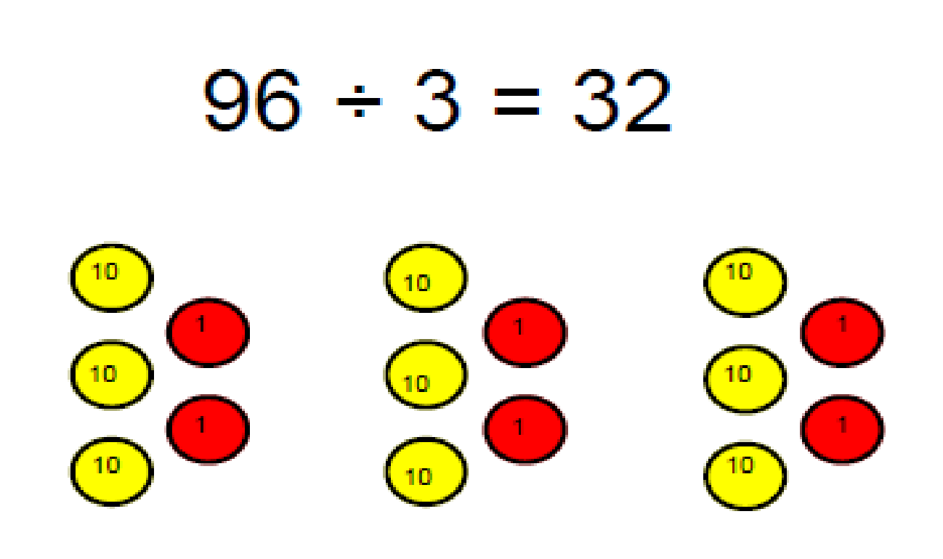  Place the ‘groups of 5’ on top or underneath the 20. How many ‘5s’? Make clear links to multiplication: 4 ‘5s’ - 5 x4. |  |  | 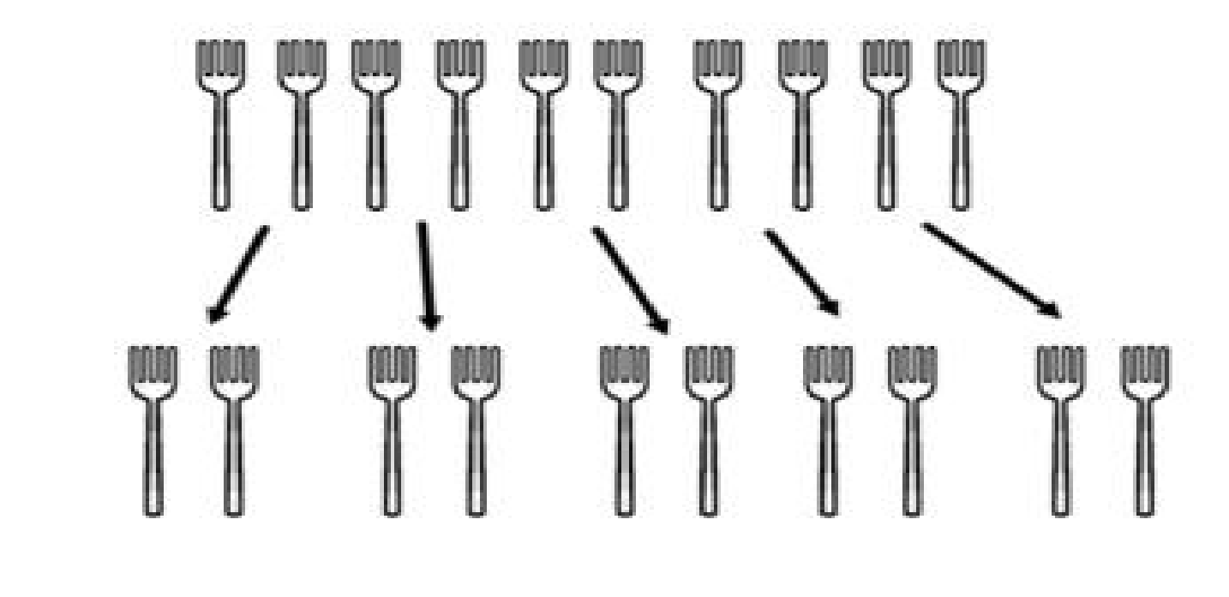  If we have ten forks and we put them into groups of two, there are 5 groups  Use a number line to show jumps in groups. The number of jumps equals the number of groups.  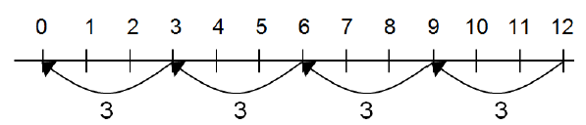  Think of the bar as a whole. Split it into the number of groups you are dividing by and work out how many would be within each group. |  |  |  |  | 10 ÷ 2 = 5  Include missing box calculations.  28 ÷ 7 = 4  Divide 28 into 7 groups. How many are in each group?
Division within arrays |  |  | 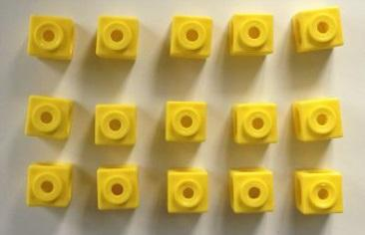  Link division to multiplication by creating an array and thinking about the number sentences that can be created.  Eg 15 ÷ 3 = 5 5 x 3 = 15  15 ÷ 5 = 3 3 x 5 = 15 |  |  | Draw an array and use lines to split the array into groups to make multiplication and division sentences.  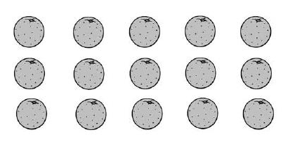. |  |  |  |  | Find the inverse of multiplication and division sentences by creating four linking number sentences (fact families)  7 x 4 = 28  4 x 7 = 28  28 ÷ 7 = 4  28 ÷ 4 = 7
Division with a remainder |  |  | 14 ÷ 3 =  Divide objects between groups and see how much is left over  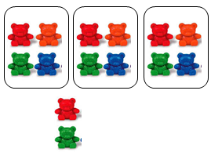  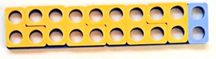  20 ÷ 3 = 6 r 2  Bead string to model reminders. |  |  | Draw dots and group them to divide an amount and clearly show a remainder.  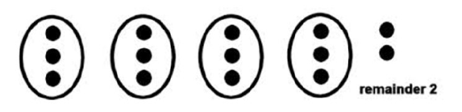  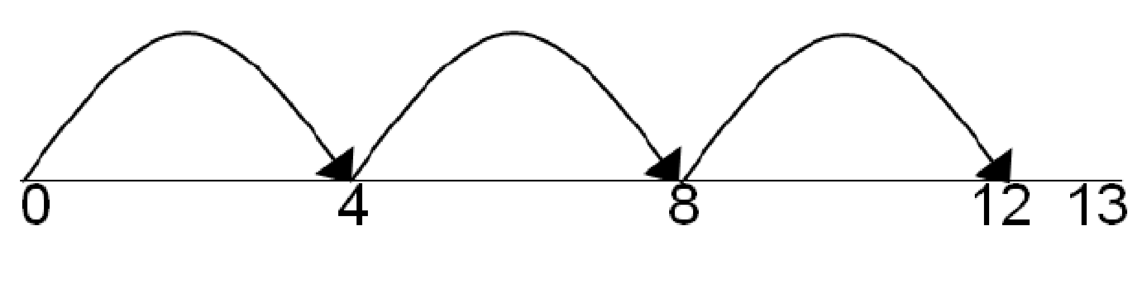  Jump forward in equal jumps on a number line then see how many more you need to jump to find a remainder. |  |  |  |  | Complete written divisions and show the remainder using r.  20 ÷ 3 = 6 r 2  You may want to note down that 6 x 3 = 18 so 6 groups with 2 remainder  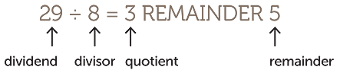  Include missing box calculations.
Short Division |  |  | Use place value counters to divide using the bus stop method alongside  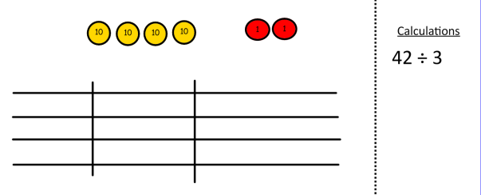  42 ÷ 3=  Start with the biggest place value, we are sharing 40 into three groups. We can put 1 ten in each group and we have 1 ten left over.  We exchange this ten for ten ones and then share the ones equally among the groups.  We look how much in 1 group so the answer is 14. |  |  | 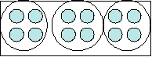  Students can continue to use drawn diagrams with dots or circles to help them divide numbers into equal groups.  Encourage them to move towards counting in multiples to divide more efficiently. |  |  |  |  | Begin with divisions that divide equally with no remainder.  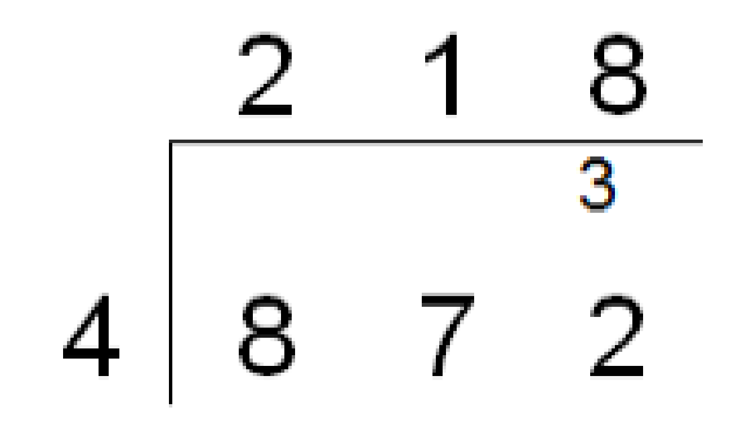  Move onto divisions with a remainder.  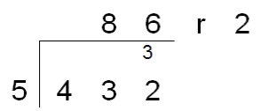  Show remainders as decimals and fractions.  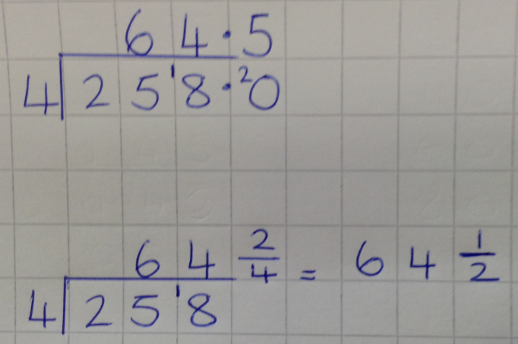  Long division  Partition the divisior to find multiples  To calculate long division the rule is: divide, multiply, subtract and drop down  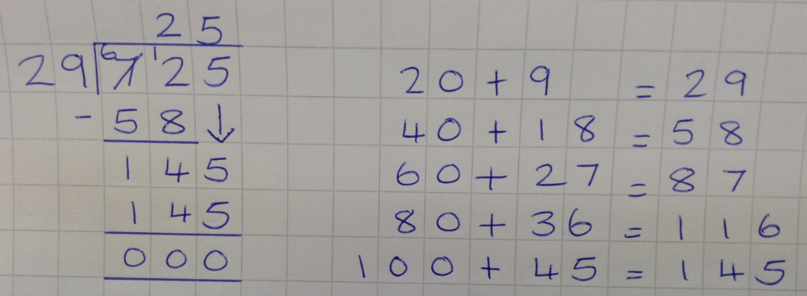  Some children may use chunking as a way to calculate long division  